**Predicting the Existence of Dyslexia in Children Using fMRI**

Final Report

Chen Cohen and Tom Beer

**Supervised by**: Yochai Blau

# Table of Contents

[Table of Contents 2](#_Toc467077171)

[Figures 6](#_Toc467077172)

[Abstract 7](#_Toc467077173)

[Abbreviations 8](#_Toc467077174)

[Introduction 9](#_Toc467077175)

[Functional MRI 10](#_Toc467077176)

[**Resting-state condition** 10](#_Toc467077177)

[**Data acquisition** 10](#_Toc467077178)

[Current Analysis 12](#_Toc467077179)

[**fMRI Pre-processing** 12](#_Toc467077180)

[**ICA** 13](#_Toc467077181)

[Non-linear Algorithms 15](#_Toc467077182)

[**Non-linear dimensionality reduction by manifold learning** 15](#_Toc467077183)

[**Computational Challenge** 16](#_Toc467077184)

[**Laplacian Eigenmaps** 17](#_Toc467077185)

[Single subject dimensionality reduction results 18](#_Toc467077186)

[Clustering 20](#_Toc467077187)

[**K means** 20](#_Toc467077188)

[10 Slices Analysis 20](#_Toc467077189)

[Full Brain Analysis – LEM only 21](#_Toc467077190)

[Group Analysis 22](#_Toc467077191)

[**Alignment** **Check** 22](#_Toc467077192)

[**Temporal Concatenation** 23](#_Toc467077193)

[Typical Group 25](#_Toc467077194)

[Dyslexics Group 27](#_Toc467077195)

[**Mean Eigen Decomposition** 29](#_Toc467077196)

[Typical Group 31](#_Toc467077197)

[Dyslexics Group 33](#_Toc467077198)

[**Qualitative comparison between the two methods** 35](#_Toc467077199)

[**Comparison to the current analysis methods** 35](#_Toc467077200)

[Summary 37](#_Toc467077201)

[References 38](#_Toc467077202)

[Appendices 39](#_Toc467077203)

[**Appendix 1 – Additional results for single subject analysis using different values nearest neighbors** 39](#_Toc467077204)

[Typical study, 10 dimensions, 10 nearest neighbors 39](#_Toc467077205)

[Typical study, 10 dimensions, 12 nearest neighbors 40](#_Toc467077207)

[Typical study, 10 dimensions, 14 nearest neighbors 41](#_Toc467077208)

[Typical study, 10 dimensions, 16 nearest neighbors 42](#_Toc467077209)

[Typical study, 10 dimensions, 18 nearest neighbors 43](#_Toc467077210)

[Typical study, 10 dimensions, 20 nearest neighbors 44](#_Toc467077211)

[**Appendix 2 – Additional results for temporal concatenation group analysis using different values of $σ$**  45](#_Toc467077213)

[, Typical Group 45](#_Toc467077214)

[, Typical Group 47](#_Toc467077215)

[**Appendix 3 – Additional results for mean eigen decomposition group analysis using different block sizes** 49](#_Toc467077216)

[Typical Group, 10 iterations, block size 100 49](#_Toc467077217)

[Typical Group, 10 iterations, block size 500 51](#_Toc467077218)

[**Appendix 4 – Additional results for mean eigen decomposition group analysis after clustering using K means** 53](#_Toc467077219)

[Typical Group, 10 iterations, block size 1000 53](#_Toc467077220)

[Dyslexic Group, 10 iterations, block size 1000 54](#_Toc467077221)

# Figures

**Figure 1** – an example of the structural and the functional images 9

**Figure 2** – temporal behavior of a specific voxel in different slices of the brain, over 180 samples 9

**Figure 3** – fMRI data pipeline. A flow chart illustrating the pipeline used to process the multi-subject fMRI data through the group independent component analysis (ICA) and back projection 12

**Figure 4** - Dimensionality reduction using LEM algorithm for a single control study. 17

**Figure 5** – Dimensionality reduction using LLE algorithm for slices 21-30 from a single control study, number of dimensions: 10. 18

**Figure 6** – Dimensionality reduction using LEM algorithm for slices 21-30 from a single control study. 19

**Figure 7** - Dimensionality reduction using LEM algorithm for a full single control study. 19

**Figure 8** – Anatomical alignment check for 2 control studies 21

**Figure 9** – Functional alignment check for several control studies, using a temporal average for each voxel. 21

**Figure 10** – Temporal concatenation flow chart 22

**Figure 11** – Group dimensionality reduction using temporal concatenation. 17 typical studies, Number of dimensions: 20, 10 nearest neighbors, sigma 1, no clustering. 24

**Figure 12** - Group dimensionality reduction using temporal concatenation. 21 dyslexic studies, Number of dimensions: 20, 10 nearest neighbors, sigma 1, no clustering. 26

**Figure 13** – Mean Eigen decomposition flow chart 27

**Figure 14** - Group dimensionality reduction using mean eigen decomposition. 17 typical studies, Number of dimensions: 20, 10 nearest neighbors, sigma 1, no clustering. 10 iterations, block size 1000. 30

**Figure 15** - Group dimensionality reduction using mean eigen decomposition. 21 dyslexic studies, Number of dimensions: 20, 10 nearest neighbors, sigma 1, no clustering. 10 iterations, block size 1000. 32

**Figure 16** – group ICA results for 17 typical studies 34

# Abstract

Dyslexia is a learning disorder characterized by difficulties with accurate or fluent word recognition and by poor spelling and decoding abilities. Current diagnosis of dyslexia lacks objective criteria, which can decrease treatment efficacy. Diagnosis relies on a discrepancy between reading ability and intelligence, a measure which can be unreliable, and has been criticized for its poor validity.

Functional magnetic resonance imaging (fMRI) is a fairly new and unique tool that enables widespread, noninvasive investigation of brain functions. A growing body of studies are exploring the use of resting state fMRI techniques in examining possible functional disconnectivity effects in neurologic and psychiatric brain disorders, including Alzheimer's disease, depression, dementia and schizophrenia. Functional connectivity is defined as the temporal dependency of neuronal activation patterns of anatomically separated brain regions. Therefore, functional connectivity studies have the potential to characterize and classify brain disorders such as dyslexia, too.

In the past two decades, a variety of methods have been proposed to analyze functional connectivity. Amongst these methods, independent component analysis (ICA) has become an increasingly utilized data driven approach for fMRI analysis. Nearly all used methods, ICA included, are linear algorithms and as such, they assume linearity of the data.

This assumption may not hold true for resting state fMRI data, and so in this project we examine and propose novel approaches for functional connectivity studies, that are non-linear and make no prior assumptions on the nature of the data.

# Abbreviations

**fMRI** functional magnetic resonant imaging

**BOLD** blood oxygen level dependent

**ICA** independent component analysis

**PCA** principal component analysis

**LEM** laplacian eigen maps

**DM** diffusion maps

**LLE** locally linear embedding

**HLLE** Hessian LLE

**KPCA** kernel PCA

**LTSA** local tangent space alignment

**SVD** singular value decomposition

# Introduction

In this project, our objective was to propose, implement and examine new unexplored methods for the processing and analysis of fMRI data, with hope for improving present approaches for functional connectivity study and dyslexia prediction.

At first, we reviewed fMRI as a neuroimaging modality and its produced signals. Then, we focused on Independent Component Analysis, a prominent tool in fMRI connectivity research, in order to understand the existing state and its limitations. Later on, we turned to prospect advanced non-linear algorithms that could help infer meaningful clinical results. Finally, we extended our methodology from single subject to multi subject analysis, via two distinct approaches

This project was done in collaboration and with great help from Prof. Tzipi Horowitz-Kraus, director of the Educational Neuroimaging Center in Technion's Faculty of Education in Science and Technology. She turned to the Signal and Image Processing Lab and asked for its help in exploring new approaches for the aid of her research interests: finding connections between reading disorders and neuroimaging results. Thanks to her we acquired the fMRI scans, a total of 20 studies for each of the two groups: children diagnosed with Dyslexia and typical cases (for control).

# Functional MRI

Functional MRI is a neuroimaging technique used to map active brain areas responsible for performed tasks (such as thought, speech, movement, and sensation). By measuring blood oxygen level dependent (BOLD) signal changes, fMRI detects active regions of the brain. Functional connectivity is defined as the temporal dependency of neuronal activation patterns of anatomically separated brain regions. In the past years an increasing body of neuroimaging studies has started to explore functional connectivity by measuring the level of co-activation of resting-state fMRI time-series between brain regions.

## **Resting-state condition**

During resting-state scans, patients are instructed to relax and not to think of something in particular, while their level of spontaneous brain activity is measured. A fast growing amount of neuroimaging studies support the notion that the observed temporal correlation between fMRI time-series of anatomically separated regions is reflecting a level of ongoing functional connectivity between brain regions during rest. This makes spontaneous resting-state fMRI oscillations a robust measure to examine functional connections between brain regions on a whole-brain scale‎ [1].

## **Data acquisition**

All images were acquired on a Philips Achieva 3 T MRI scanner (Philips Medical Systems, Best, The Netherlands). A T2\*-weighted, gradient-echo planar imaging (EPI) sequence was used with fMRI parameters: TR/TE = 2000/38 ms, matrix size = 64 × 64, slice thickness = 5 mm, resulting in a voxel size = 4 × 4 × 5 $mm^{3}.$ Artifacts at this long echo time were minimized using a SENSE factor of 2 in a 32-channel RF head coil. During the resting-state scan, 165 whole-head volumes were acquired for a total imaging time of 5.5 min. The initial 10 time points acquired were discarded to allow for T1 relaxation equilibrium. In addition, a high-resolution T1-weighted 3D anatomical scan was acquired using an inversion-recovery-prepared turbo gradient-echo acquisition protocol with a spatial resolution of 1 × 1 × 1 mm.

Every study contains the structural images (256 slices of 192x256 images) and the functional information (37 slices of 64x64 images, practically 150K voxels, over 180 time points).

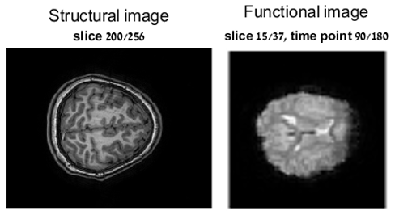

Figure – an example of the structural and the functional images

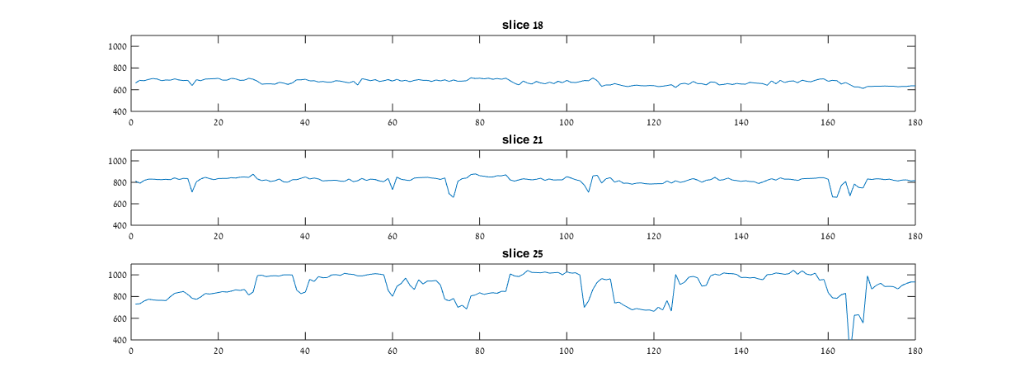

Figure – temporal behavior of a specific voxel in different slices of the brain, over 180 samples

# Current Analysis

## **fMRI Pre-processing**

After acquisition, the data undergoes a sequential combination of spatio-temporal image processing steps that are referred to as fMRI preprocessing. We received the data after the following preprocessing steps:

**Slice-Time Correction:** Adjusting the fMRI signal of every slice in order to correct for the fact that not all slices were actually acquired at the same time. Slice-Time correction interpolates the signal of each slice to the timing of a desired reference slice in order to account for this temporal discrepancy.

**Realignment/Motion Correction**: Realigning each volume of the fMRI series to a reference volume using a 6-parameter affine transformation (rotation and translation about and in the x, y, and z axes). This is meant to correct for movement of the participant’s head in the scanner during acquisition.

**Co-registration**: Registering the fMRI image to the anatomical using an affine transformation. Co-registration is meant to account for any participant head movement between the acquisition of the anatomical data and the acquisition of the fMRI data.  
**Normalization**: Aligning images in order to remove structural variability of different brains. Images are aligned to the Montreal Neurological Institute (MNI) template, which was found to be appropriate for children age 5 and above

**Spatial smoothing**: applying a 3D spatial smoothing kernel to each fMRI volume, of 8mm FWHM in each direction. Smoothing of fMRI data is generally done in an attempt to “average out” some of the random noise while maintaining neural activity-related signal.

## **ICA**

Independent component analysis is a recently developed popular method for functional connectivity detection using fMRI. Since it needs no prior information about the spatial or temporal patterns of source signals, ICA is well suited for resting-state fMRI study. Like PCA, ICA seeks to find a linear combination of components. The difference is that ICA would find components that are as statistically independent as possible, while PCA would find components with maximal variance. For fMRI data X (T time points × N voxels), the ICA model can be expressed as:

$$X=AC= \sum_{i=1}^{N}{A_{i}C_{i}}$$

Where Ci is the ith underlying signal source; A is the mixing matrix with a dimension of T × N. Different sources are independent from each other:

$$P\left(C_{1},∙∙,C_{N}\right)= \prod_{i=1}^{N}{P(C_{i})}$$

ICA-based methods are perhaps the most commonly used and have been reported to show a high level of consistency‎ [1], ‎[2]. ICA methods for resting-state fMRI are powerful as statistical independence is considered to be a reliable discriminator between functional networks. In addition, ICA can be easily applied to whole-brain voxel-wise data, and after application the temporal signals of the independent components can be selected for further examination of possible group differences between healthy controls and patients.

Figure 3 provides an example of a typical processing pipeline of fMRI data, as is done in the studies of Prof. Tzipi Horowitz-Kraus. It can be seen that ICA plays a key role in such processing pipeline.

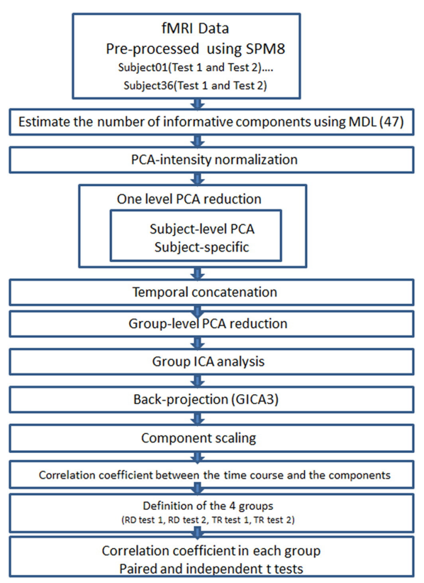

Figure 3 – fMRI data pipeline. A flow chart illustrating the pipeline used to process the multi-subject fMRI data through the group independent component analysis (ICA) and back projection

# Non-linear Algorithms

Linear algorithms are based on the assumption of linear data mixing. Conversely to the extensive use of linear algorithms like ICA and PCA in the processing of fMRI data, this assumption may not be accurate for brain activity. Studies have observed nonlinearity in resting state fMRI BOLD signals‎ [4] ‎[5] ‎[6]. The results of these studies suggest that the mechanics of the hemodynamic response to neuronal activation may be more completely understood by the application of nonlinear time series analysis. For this reason we turned to test nonlinear dimensionality reduction techniques as an alternative to conventional linear clustering algorithms.

## **Non-linear dimensionality reduction by manifold learning**

A family of geometrically motivated approaches to data analysis, whose unifying premise is the assumption that many types of high-dimensional natural data lie on or near a low dimensional manifold. These include isomap, locally linear embedding, diffusion maps, laplacian eigenmaps and many more.

The tested algorithms are the following:

**LTSA -** Local tangent space alignment is a dimensionality reduction method which aims to align all tangent hyperplanes to the data points, and by that to learn the underlying manifold.

**Diffusion maps** is a dimensionality reduction and feature extraction algorithm that is based on concepts from Riemannian geometry, and exploits the relationship between [heat diffusion](https://en.wikipedia.org/wiki/Heat_diffusion) and random walk [Markov chain](https://en.wikipedia.org/wiki/Markov_chain).

**Locally linear embedding** computes a lower-dimensional projection of the data which preserves distances within local neighborhoods.

**Hessian LLE** is a variant of LLE that minimizes the ‘curviness’ of the high-dimensional manifold when embedding it into a low-dimensional space, under the constraint that the low-dimensional data representation is locally isometric. This is done by minimizing the Hessian functional on the manifold.

**Laplacian Eigenmaps** is a dimensionality reduction algorithm similar to LLE. It finds a low-dimensional data representation by preserving local properties of the manifold, which are based on the pairwise distances between near neighbors.

**Kernel principal component analysis (K-PCA)** is an extension of principal component analysis. Using a kernel, the originally linear operations of PCA are done in a reproducing kernel Hilbert space with a non-linear mapping.

**Computational Challenge**

Due to the large amount of data points (about 150,000), most data processing techniques lose practical feasibility. Either they are intractable (consume too much time) or introduce memory issues. Consequently, all but a few of the many algorithms that were tested have failed to provide an output. A threshold requirement for any algorithm is its memory-wise implementation. Data processing algorithms perform operations on matrices of size NxN, where N is the number of signals (a covariance matrix in most linear methods, and a distance matrix in most non-linear methods). In the case of our fMRI data, this translates to a memory requirement of $\frac{{150,000}^{2}}{{1024}^{3}}=167GB$ just for a single study analysis, which of course is not feasible. Therefore, only algorithms that maintain a sparse NxN matrix have the potential to provide results, and so only they were tested on a full brain. Such algorithms are LLE, H-LLE, LTSA and LEM, which compute a K-nearest neighbors distance matrix. Since K is much smaller than the number of data points, the generated similarity matrix is sparse, and can be stored in a memory efficient manner.

Out of the above four methods, only LEM has succeeded in handling the whole brain volume. Others either never finished running or resulted in unsolvable errors. For this reason all algorithms were tested too on a smaller scale of 10 slices (out of the original 46 slices). Here also most algorithms did not prove useful, and only LEM and LLE returned the partial results.

## **Laplacian Eigenmaps**

A manifold learning technique that preserves locality (by means of distances between data points) in the embedding from high dimension to low dimension space. The transform emphasizes the natural clusters in the data and so it can be helpful for clustering, and indeed it has a strong relation to spectral clustering‎ [6]. The locality preservation criterion can be formulated as:

$$\min_{y_{i} }\sum_{i=1}^{N}{\sum_{j=1}^{N}{{\left(y_{i}-y_{j}\right)}^{2} W_{ij}}}$$

Where Wij is the pairwise similarity between data points (measured by Euclidean distance). This objective can be reformulated into:

$$\min_{Y }Tr\left(YLY^{T}\right)$$

Where Y is a matrix whose columns are yi and L is the graph laplacian, defined by L=D-W, and D=diag(sum(W)). The solution is provided by the eigenvectors of the generalized eigenvalue problem Ly = λDy.

The algorithm‎ [7]

1. Construct the distance graph (choose between ε-neighborhood and k nearest neighbors.)
2. Apply weights (choose between a heat kernel ($W_{ij}=exp⁡(-\frac{\left\|x_{i}\right.{\left.{-x}_{j}\right\|}^{2}}{σ^{2}})$) and simple minded weights (Wij=1 if nodes are connected, otherwise 0)).
3. Assume the graph G constructed above is connected. Otherwise, proceed with step 3 for each connected component. Compute eigenvalues and eigenvectors for the generalized eigenvector problem Ly = λDy, where D and L are defined as above.

Input parameters

According to the above description, the algorithm is influenced by three main parameters:

1. k: Determines the number of nearest neighbors that will be saved for each data point.
2. d: Determines the dimensionality of the analyzed data. It is the number of smallest eigenvalues and eigenvectors extracted, as each eigenvector is a different dimension in the embedded space.
3. σ: Sets the width (variance) of the Gaussian kernel applied to the distances in the nearest neighbor adjacency matrix. It determines which distances are considered close and which are not. This parameter is always set according to the maximal distance in the nearest neighbor matrix (each row is divided by the maximal distance from the related data point).

### Single subject dimensionality reduction results

In the single subject analysis, we tested k values of 10 up to 20. The different k values did not significantly affect the output, so from this point on we fixed k to be 10, to reduce computational complexity. The following results are for 10 nearest neighbors, and results for different choices of k are available in appendix 1. We tested d values of 10 and 15, but the added dimensions did not provide additional information so the following results are for embedded dimensionality of 10. At this stage, we did not experiment with different values of σ.

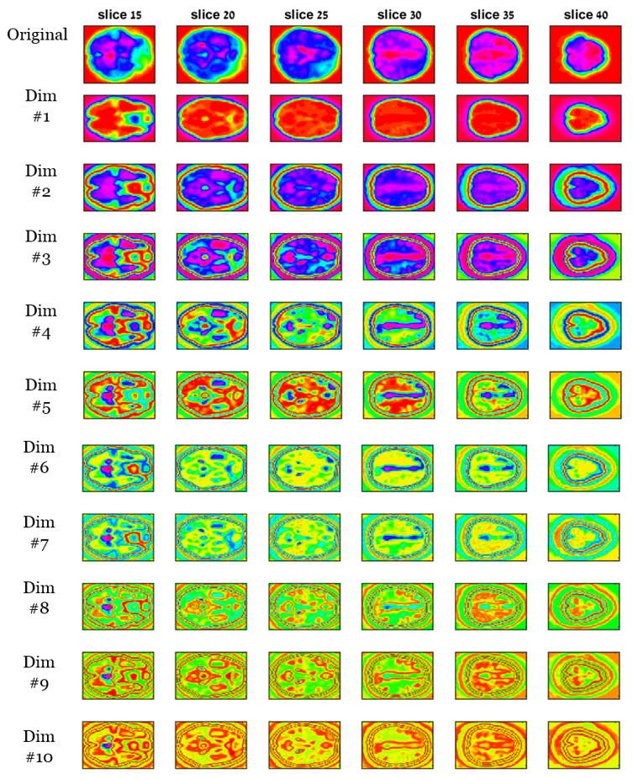

Figure - Dimensionality reduction using LEM algorithm for a single control study.

Number of dimensions: 10, 10 nearest neighbors. No clustering.

To our impression, these results lack significant features, which implies that analysis based on time courses originating from a single subject suffers greatly from noise.

# Clustering

## **K means**

Clustering is the process of partitioning a volume of data points into a small number of groups, or clusters. K-means is one of the simplest unsupervised learning algorithms that solve this task. The algorithm finds the positions ${\vec{μ}}_{i}$ of the clusters that minimize the distance from data points to the cluster. In other words, K-means solves‎ [8]:

$${argmin}_{c }\sum_{i=1}^{k}{\sum_{x∈c_{i}}{d(\vec{x},}}\vec{μ})$$

Where ci is the set of point that belong to cluster i. In our case, as in most cases, the distance metric is the squared Euclidean, so the algorithms solves:

$${argmin}_{c }\sum_{i=1}^{k}{\sum_{x∈c_{i}}{ (\vec{x}-}}\vec{μ}){(\vec{x}-\vec{μ})}^{T}$$

### 10 Slices Analysis

**LLE**

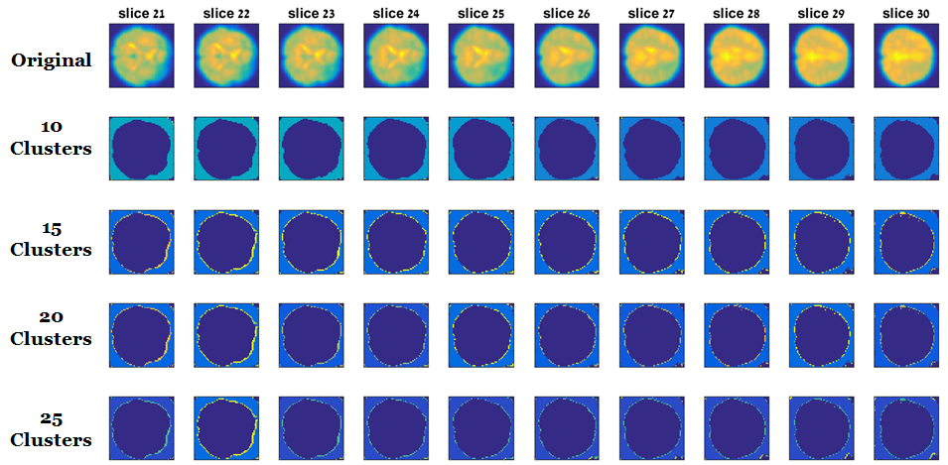

Figure – Dimensionality reduction using LLE algorithm for slices 21-30 from a single control study, number of dimensions: 10.

It can be clearly seen that LLE has completely failed to provide applicable results.

**LEM**

**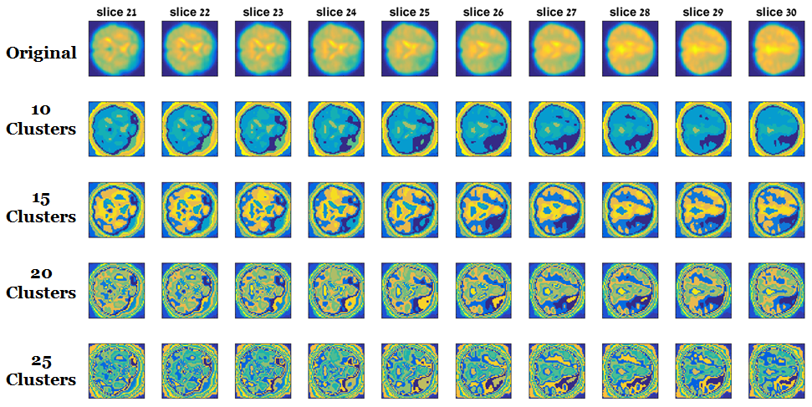**

Figure – Dimensionality reduction using LEM algorithm for slices 21-30 from a single control study.

Number of dimensions: 10, 10 nearest neighbors.

### Full Brain Analysis – LEM only

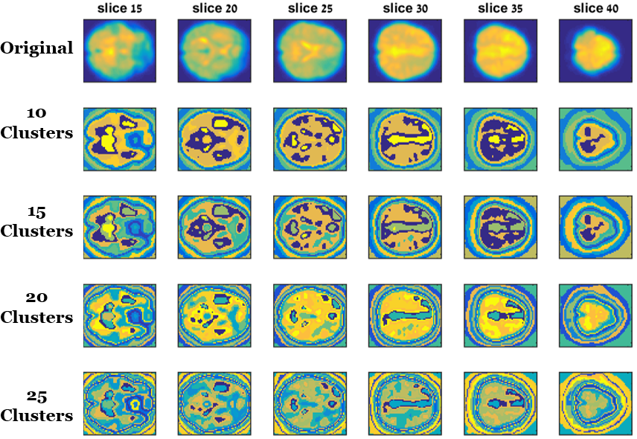

Figure - Dimensionality reduction using LEM algorithm for a full single control study.

Number of dimensions: 10, 10 nearest neighbors.

As in the no-clustering LEM analysis, here too the results are very noisy and imply that a single subject may not be enough to achieve significant applicable results.

# Group Analysis

Group analysis and inference is used in many fields when comparing studies that can be classified to specific groups. It has the potential to yield favored results in terms of robustness to noise and outliers, and at many times the produced results capture and characterize the overall behavior of the group. This becomes all the more valid in neural research studies, where single subject results are seldom used for reliable inference as they have low statistical significance. Same goes here - when examining the previous single subject results, it is clear they suffer from noise and general unsmoothness.

In this project, we extended the above methodologies to a group level analysis, by two distinct approaches.

## **Alignment** **Check**

Both prospected approaches require the data to have good structural coherence in order to provide valid results. Therefore we conducted a preliminary check to make sure the data in hand is suitable for this kind of analysis.

Unfortunately, the data that was used for the single subject analysis was not aligned at all (this does not impair the previous results, of course). With the help of Prof. Tzipi Horowitz-Kraus, we acquired new data, and as can be seen in the following figures, it is properly co-registered and normalized. This new data had a better spatial resolution (about 50% more in each dimension), so the amount of voxels increased to more than 3 times the previous amount. This confronted us with more complexity challenges.

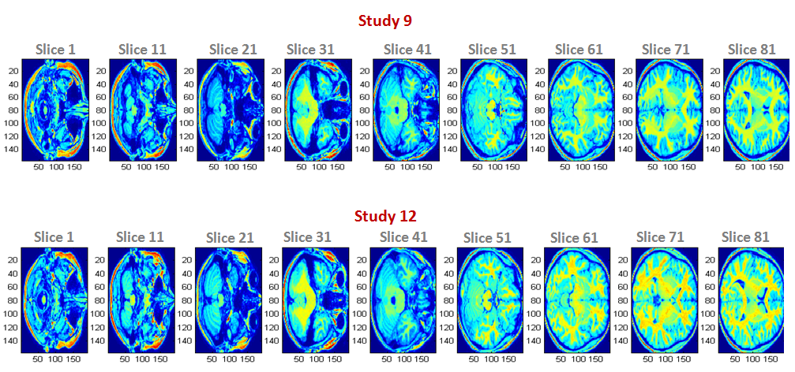

Figure – Anatomical alignment check for 2 control studies

**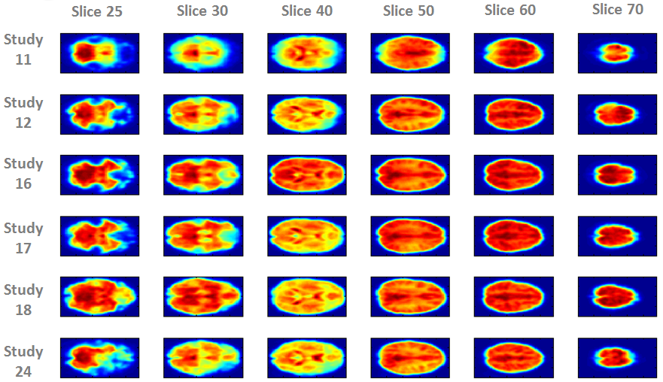**

Figure – Functional alignment check for several control studies, using a temporal average for each voxel.

## **Temporal Concatenation**

In this approach, we stacked all studies belonging to one group by their temporal dimension. This practice is regularly used in the fMRI analysis literature, a prominent example is the work of V.D Calhoun‎ [9], who generalized the ICA algorithm by temporal concatenation.

If each study's size is N voxels on T time points, and we have k studies, then the concatenated data will be of dimension N x TK. On these large matrices we apply methods previously discussed.

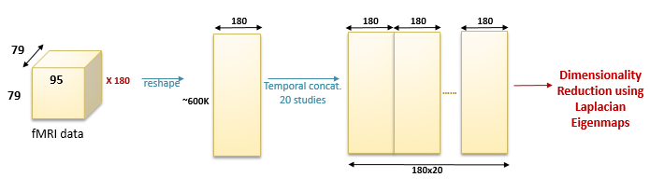

Figure – Temporal concatenation flow chart

As stated before, the new aligned data had much more spatial signals. In order to cut running-time to a practical level, we truncated the top and bottom of the brain volume, and analyzed slices 25 to 70.

After experimenting with different parameters in the single subject analysis, in this case we fixed two of them: we used a 10 nearest neighbors distance matrix, and extracted the 20 first dimensions. As opposed to the single subject analysis, here we experimented with different values of σ: we tested values of 0.5, 1 and 1.5. The following results are for σ of 1, see appendix 2 for results using the different choices of σ.

### Typical Group

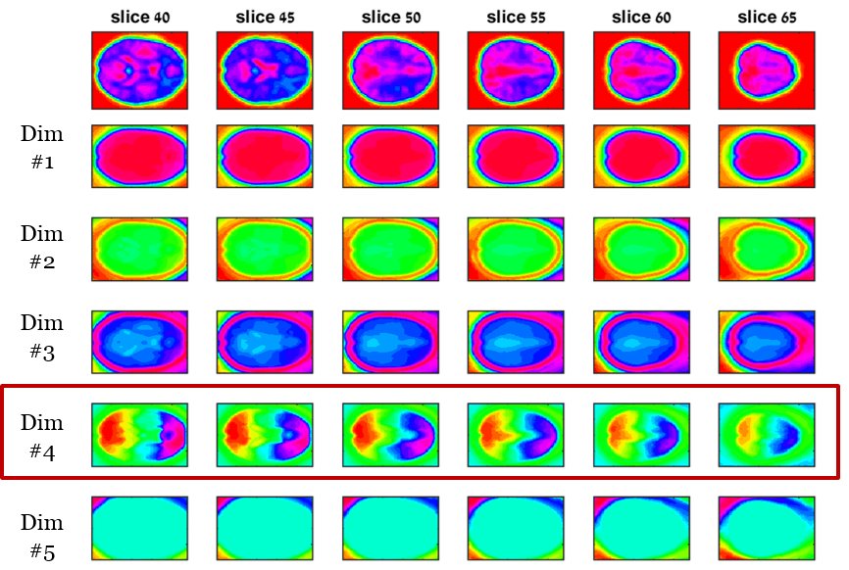 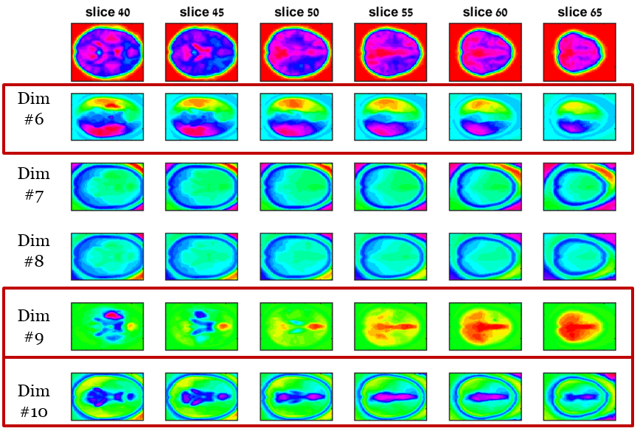 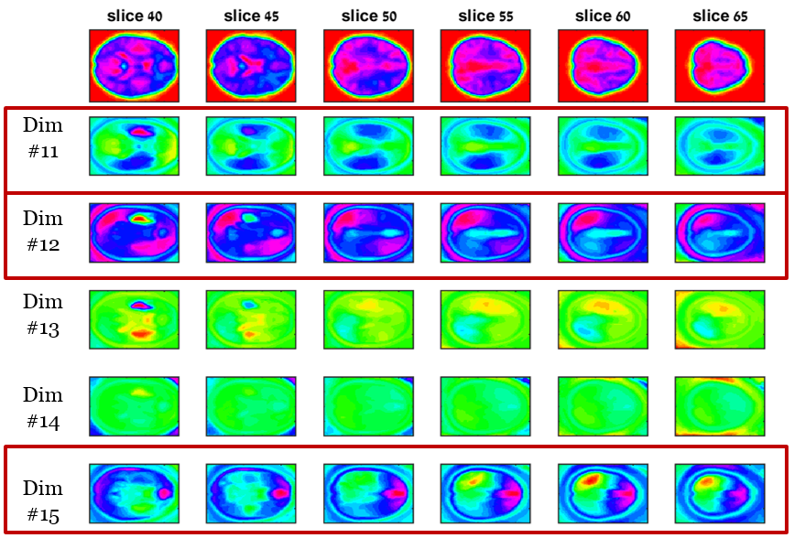 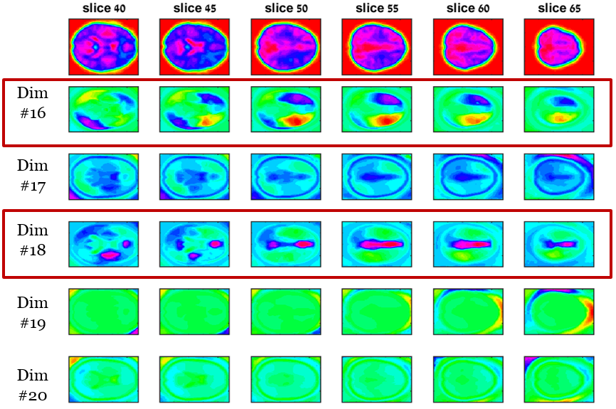

Figure – Group dimensionality reduction using temporal concatenation. 17 typical studies, Number of dimensions: 20, 10 nearest neighbors, sigma 1, no clustering.

### Dyslexics Group

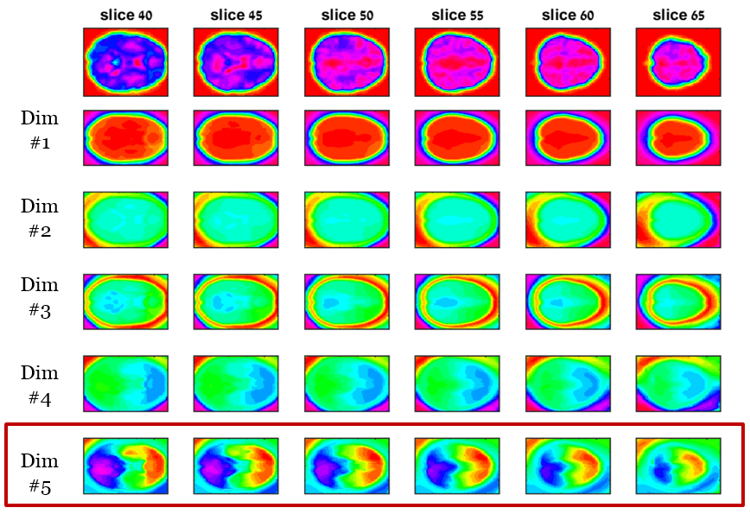 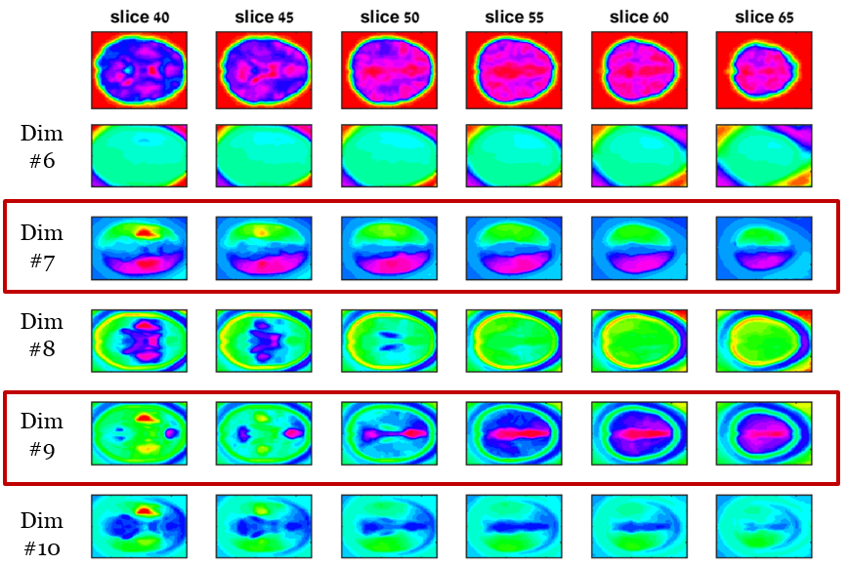 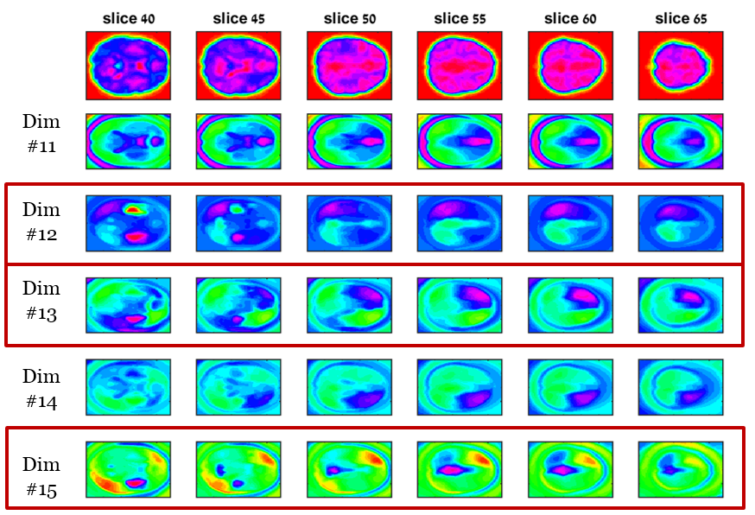 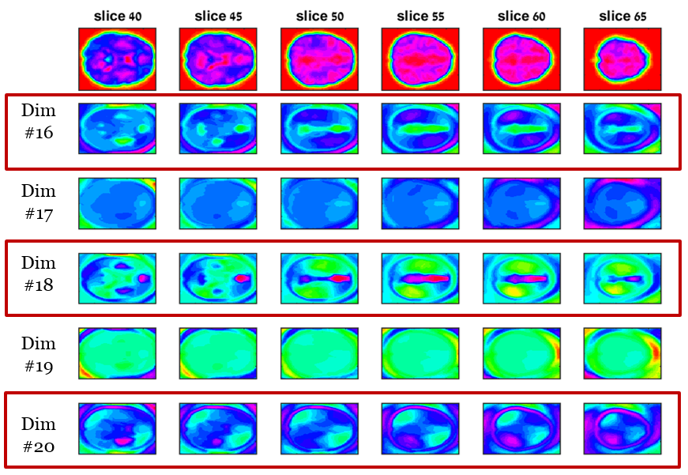

Figure - Group dimensionality reduction using temporal concatenation. 21 dyslexic studies, Number of dimensions: 20, 10 nearest neighbors, sigma 1, no clustering.

## **Mean Eigen Decomposition**

In this approach, for each study we computed the weighted similarity matrix G, as mentioned previously. Then, we averaged all weight matrices belonging to the same group, in order to achieve a generalized representation of the similarity between different brain areas within the group. After that we continued with the laplacian eigenmaps algorithm using the average weight matrix by computing its eigenvalue decomposition.

Since different studies have different connectivity profiles, the average weight matrix turned out to have much more non-zero elements than the single weight matrices it was comprised of. As consequence, the time complexity to solve the eigenvalue problem (step 3 in the Laplacian Eigenmaps algorithm) increased dramatically, to the extent that the 64GB PC we used ran out of memory, and we had to turn to alternative implementations for this problem. Matrices L and D are symmetric, so the eigenvalue decomposition is equivalent to the singular value decomposition. We used a randomized PCA/SVD algorithm, as described in‎ [10], to efficiently extract the desired eigenvectors.

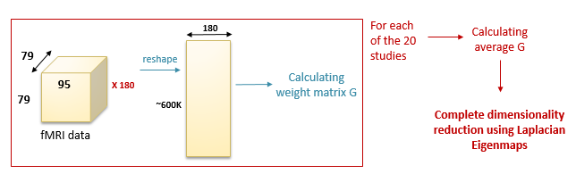

Figure – Mean Eigen decomposition flow chart

Like in the temporal concatenation approach, we fixed k and the number of dimensions to be 10 and 20, respectively, and we also fixed σ to be 1. The mentioned randomized algorithm for computing the approximated SVD has two input parameters: number of iterations and block size. Both of them are directly proportional to the output's accuracy. We tested the algorithm first on a single slice from the brain volume, and concluded that the number of iterations has a negligible effect on the outcome, but the block size greatly alters the result's accuracy and image quality. As both increase the computation time, we chose to maximize the block size within the practical limits while fixing the number of iterations. The following results are for 10 iterations and block size of 1000. More results for different block sizes are available in appendix 3.

### Typical Group

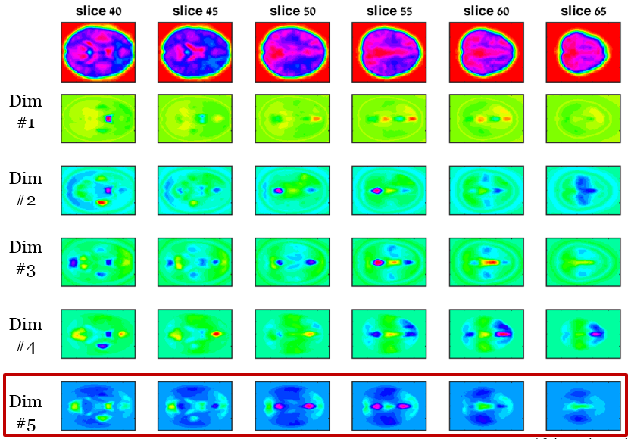 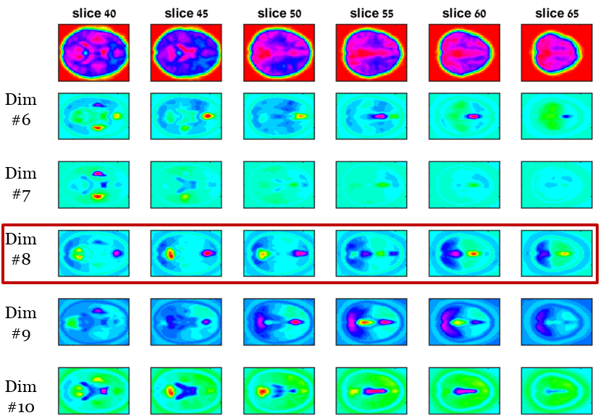 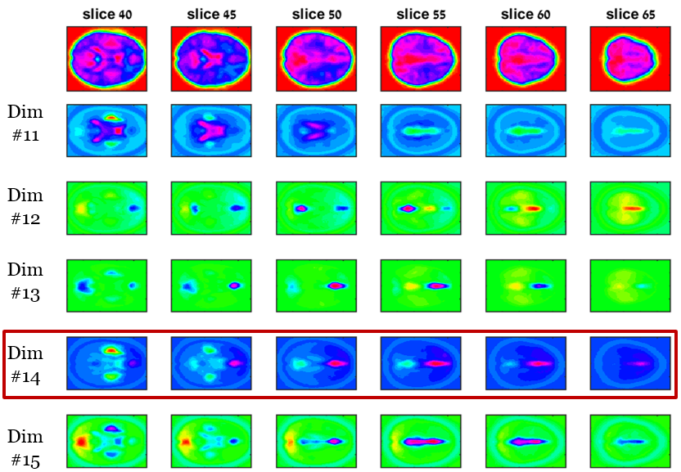 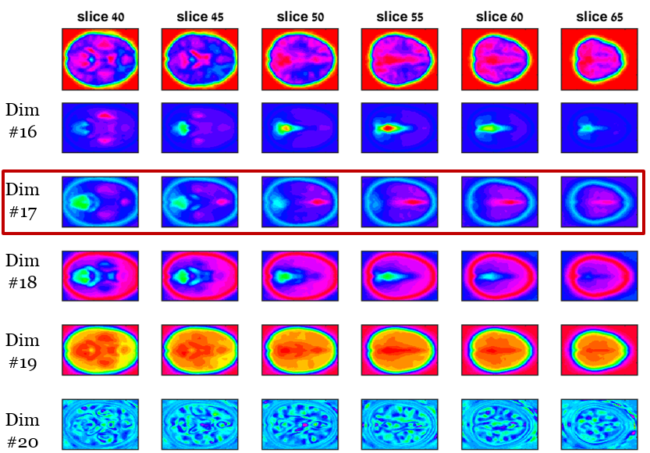

Figure - Group dimensionality reduction using mean eigen decomposition. 17 typical studies, Number of dimensions: 20, 10 nearest neighbors, sigma 1, no clustering. 10 iterations, block size 1000.

### Dyslexics Group

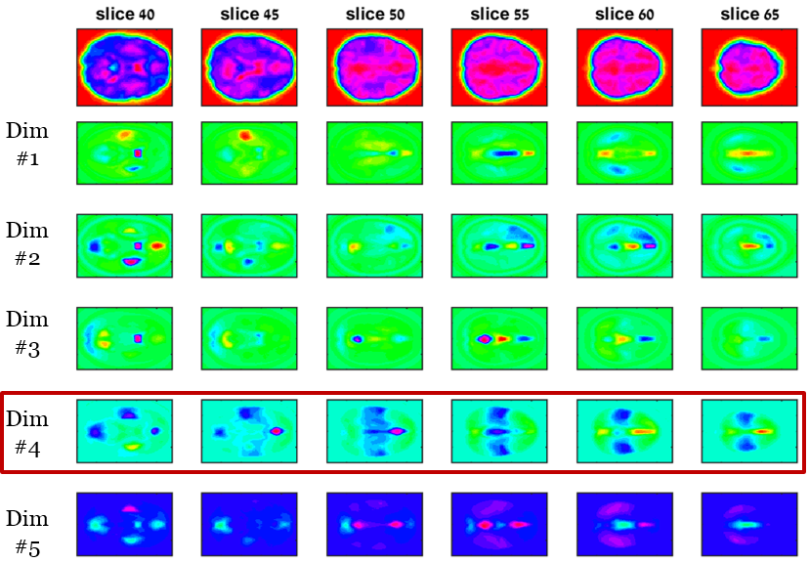 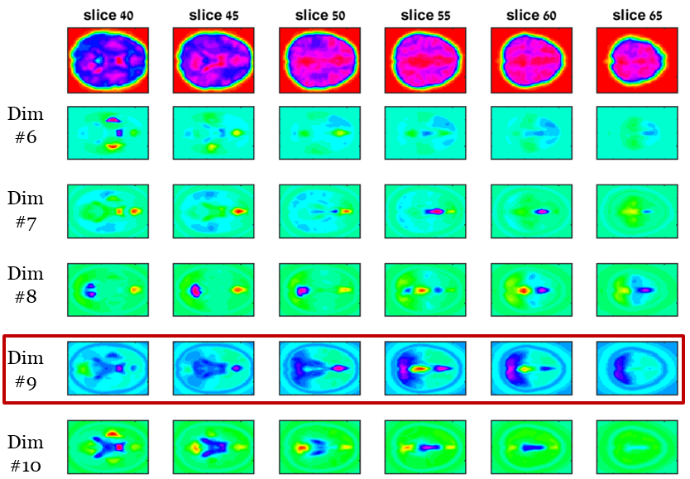 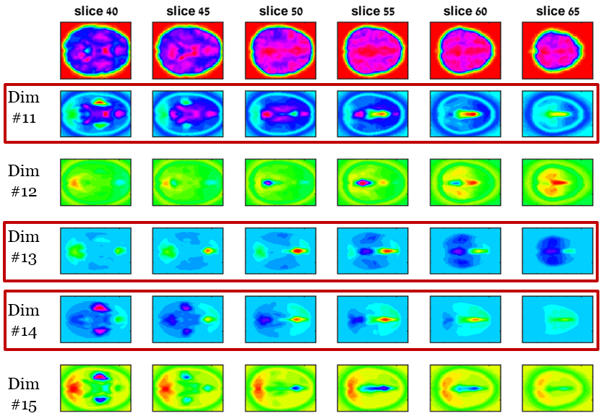 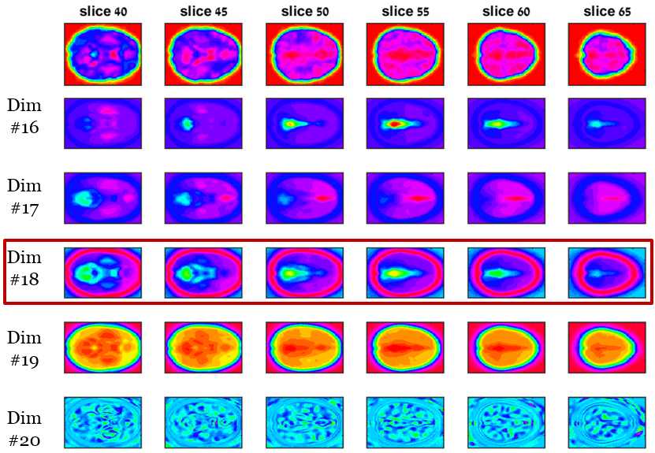

Figure - Group dimensionality reduction using mean eigen decomposition. 21 dyslexic studies, Number of dimensions: 20, 10 nearest neighbors, sigma 1, no clustering. 10 iterations, block size 1000.

## **Qualitative comparison between the two methods**

Both group analysis methods were examined with the same objective, but they provided very different results in nature. We can deduce two conclusion:

1. The mean eigen approach has succeeded to provide results that are much more local and space-defined. On the other hand, the temporal concatenation approach provided results that are more smooth and spread out.
2. In the temporal concatenation approach, many dimensions did not convey any applicable information in comparison to the mean eigen approach.

## **Comparison to the current analysis methods**

As discussed earlier, present state fMRI connectivity analysis use ICA based algorithms. In order to show the significance of the new examined approaches, we present here results obtained using a popular group ICA toolbox (GIFT).

It can be seen that these results are noisy compared to previous discussed results. This complies with the fact that before inferring from these maps, additional post processing steps are carried out by users of this approach (commonly z-score conversion and thresholding).

The results are as follows:

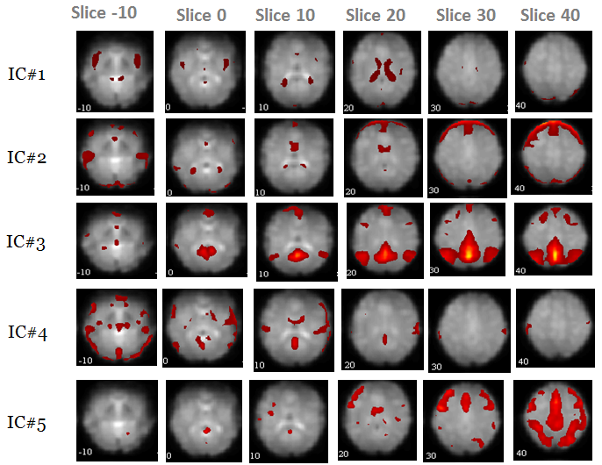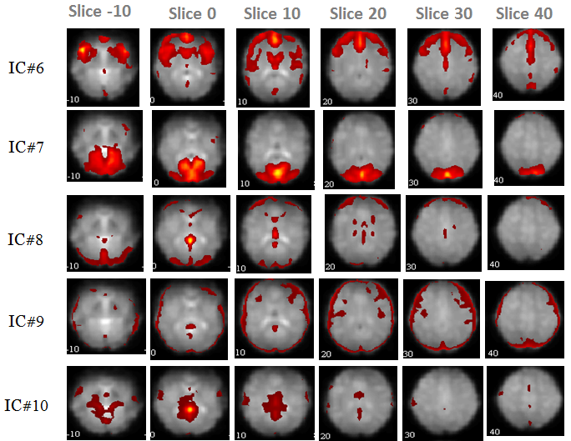

Figure – group ICA results for 17 typical studies

# Summary

In this project, we implemented and investigated new unexplored methods for the processing and analysis of fMRI data. Our principal focus was using Laplacian Eigenmaps, a manifold learning technique, in order to analyze and extract significant information from time courses of resting state fMRI scans.

This novel approach has the following qualities:

1. It reduces the dimensionality of the data, such that the low dimensional embedding gives indication of the brain's connectivity structure.
2. It is completely data driven and is not based on any kind of predefined model, region of interest etc.
3. It makes no prior assumption on the nature of the data, specifically it does not assume linearity of the data.
4. It is easy to implement and efficient in time and memory resources, in comparison to other methods we’ve tested.

After introducing the basic method, we extended it and proposed two generalized approaches for group analysis. These may prove useful when a comparison between groups is desirable, as in our case.

The results presented in this report demonstrate a clear potential of the proposed methodology for the clinical diagnosis of brain disorders. Although the results provided cannot aid in the discrimination between healthy and diagnosed subjects by themselves, they can lay the foundation for additional processing and analysis steps that could fulfil this objective. One major challenge yet to be solved is the extraction of quantitative measures from the results presented here.

# References

1. van den Heuvel MP, Hulshoff Pol HE. Exploring the brain network: a review on resting-state fMRI functional connectivity. Eur Neuropsychopharmacol 2010; 20: 519–34.
2. Li K, Guo L, Nie J, Li G, Liu T (2009) Review of methods for functional brain connectivity detection using fMRI. Comput Med Imaging Graph 33:131–139
3. Laird, A.R., Rogers, B.P., Meyerand, M.E., 2002. Investigating the Nonlinearity of fMRI Activation Data. Proceeding of the Second Joint EMBS/BMES Conference. IEEE, Houston, TX, pp. 11–12.
4. Vazquez, A. L., and Noll, D. C. 1998. Nonlinear aspects of the BOLD response in functional MRI. NeuroImage 7: 108–118.
5. Xie, X., Cao, Z., Weng, X., 2008. Spatiotemporal nonlinearity in resting-state fmri of the human brain. NeuroImage 40 (4), 1672–1685.
6. U. von Luxburg, “A tutorial on spectral clustering,” Statistics and Computing, vol. 17, 2007
7. Belkin, M., Niyogi, P.: Laplacian eigenmaps for dimensionality reduction and data representation. Neural Comput. 15(6), 1373–1396 (2003)
8. J. MacQueen, in Proceedings of the Fifth Berkeley Symposium on Mathematical Statistics and Probability, L. Le Cam, J. Neyman, Eds. (Univ. of California Press, Berkeley, CA, 1967), vol. 1, pp. 281–297.
9. Calhoun, V.D., Adali, T., Pearlson, G.D., Pekar, J.J., 2001. A method for making group inferences from functional MRI data using independent component analysis. Hum. Brain Mapp. 14 (3), 140–151.
10. V. Rokhlin, A. Szlam, and M. Tygert, A randomized algorithm for principal component analysis, SIAM J. Matrix Anal. Appl., 31 (2009), pp. 1100–1124.

# Appendices

## **Appendix 1 – Additional results for single subject analysis using different values nearest neighbors**

### Typical study, 10 dimensions, 10 nearest neighbors

## **typical_smoothed_LEM_dim10_k10_noClustering1-5**

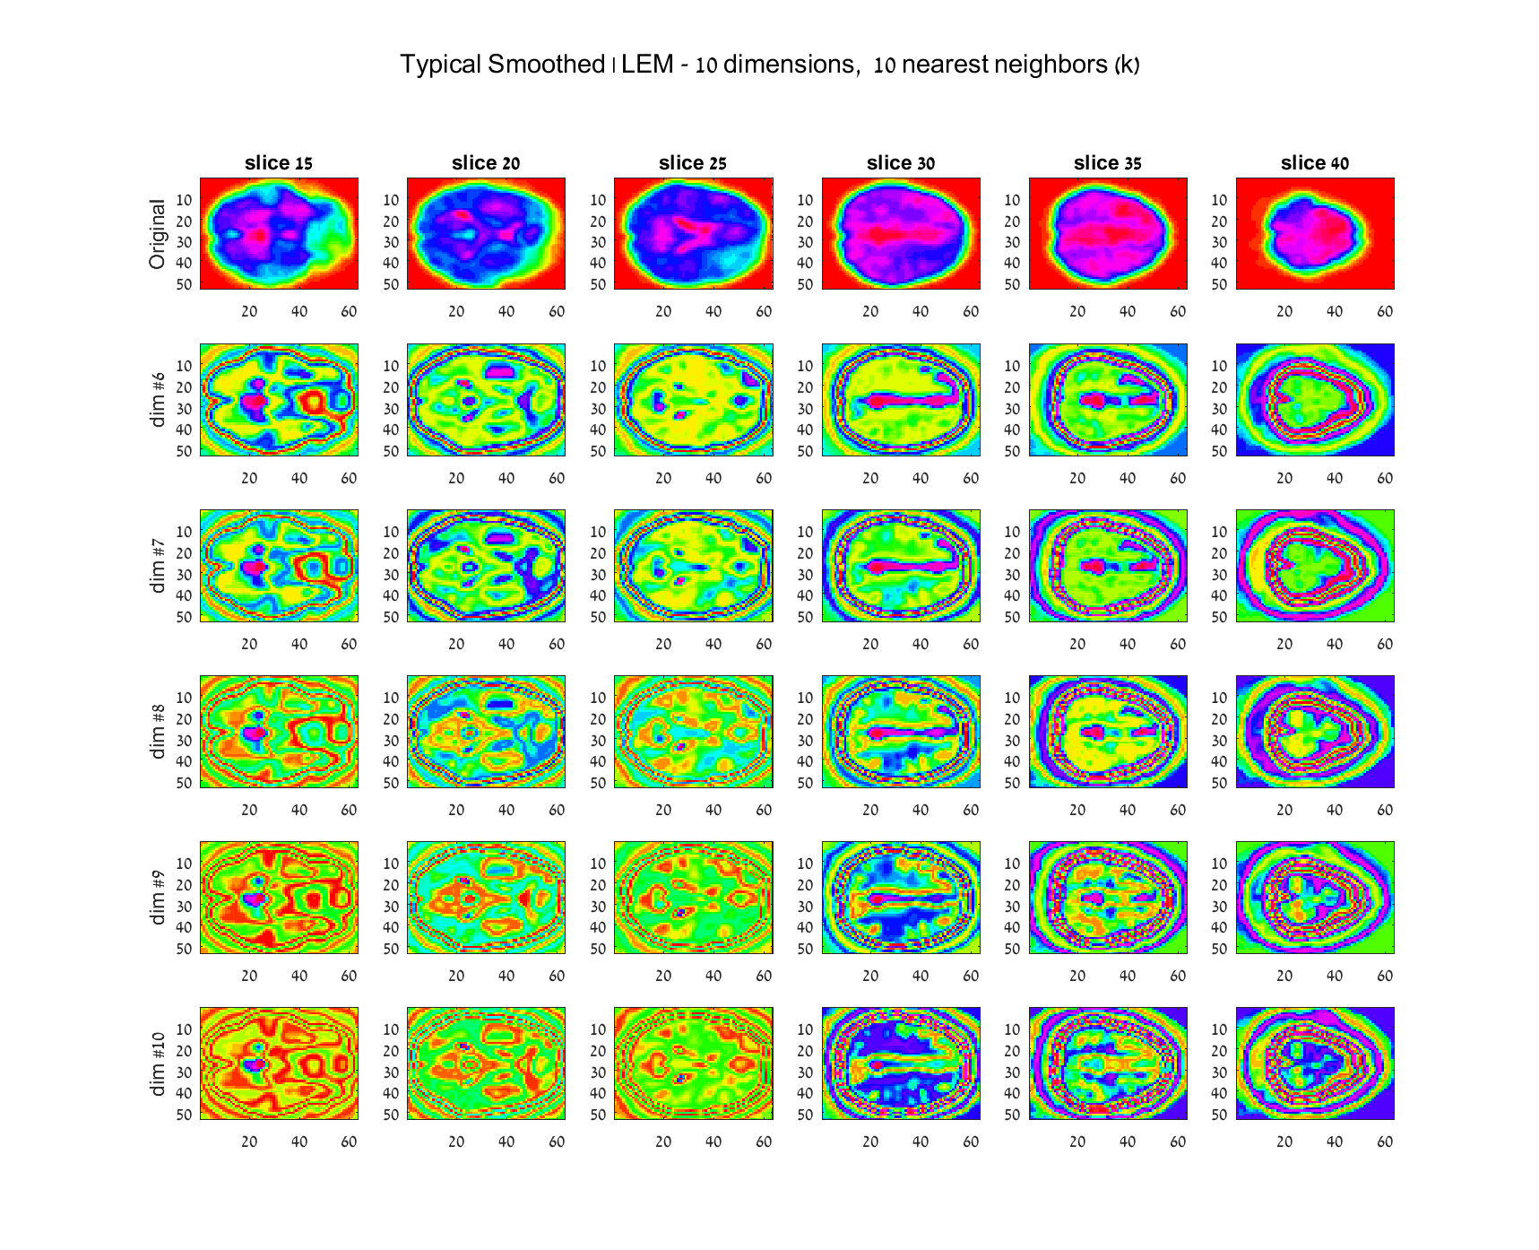

### Typical study, 10 dimensions, 12 nearest neighbors

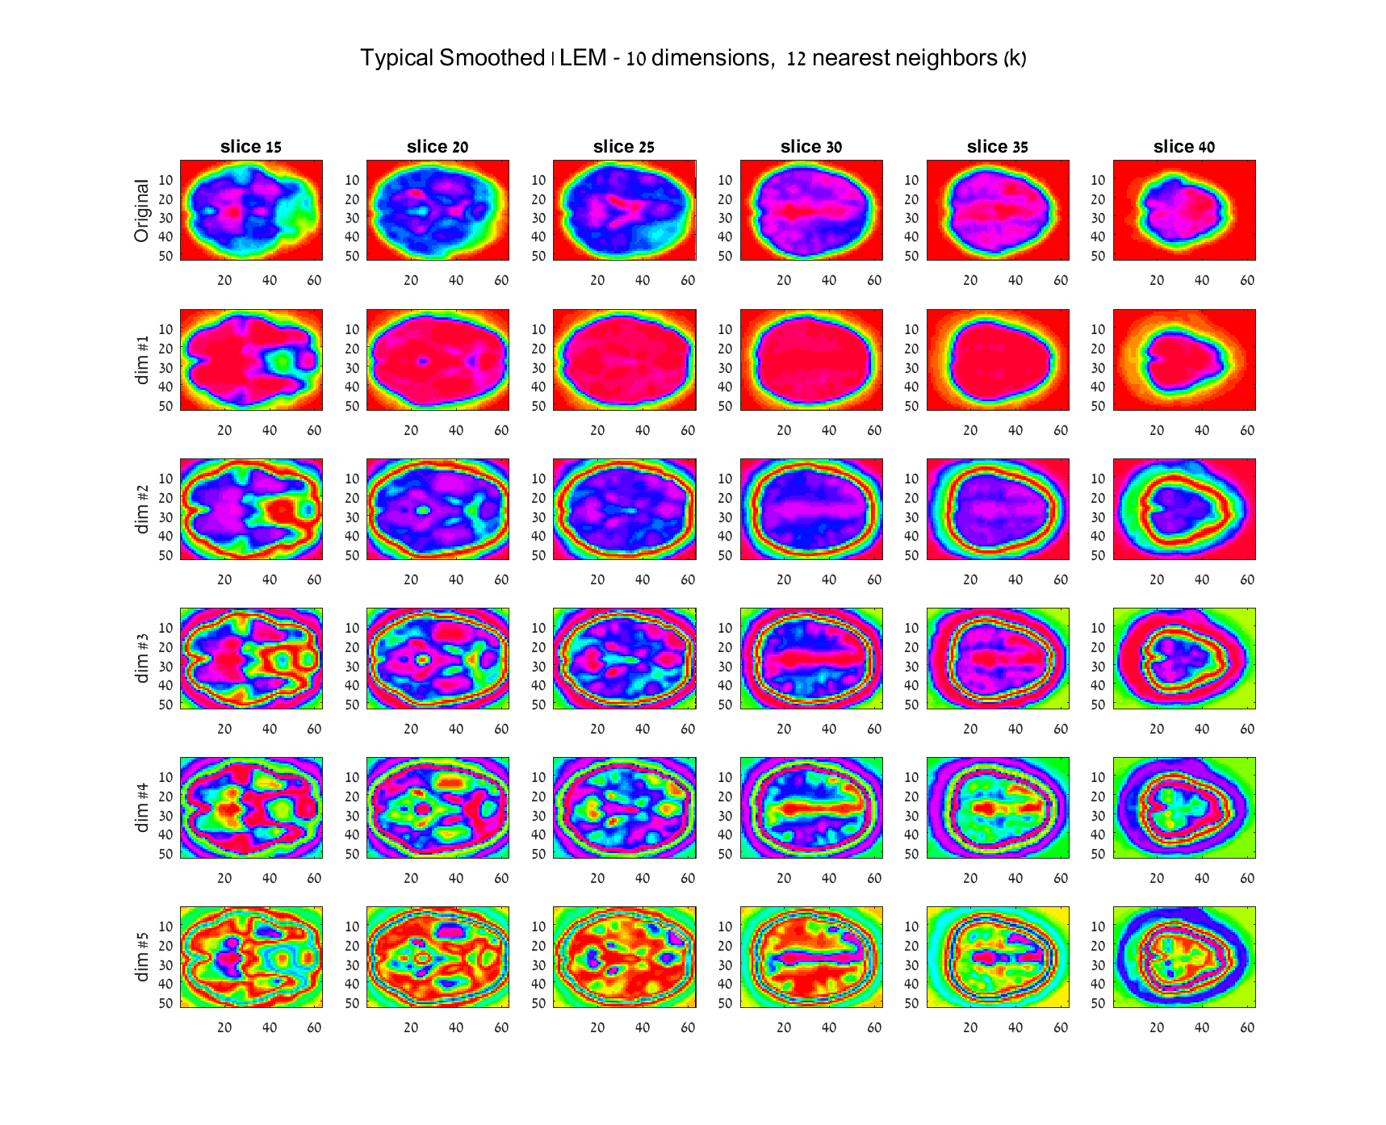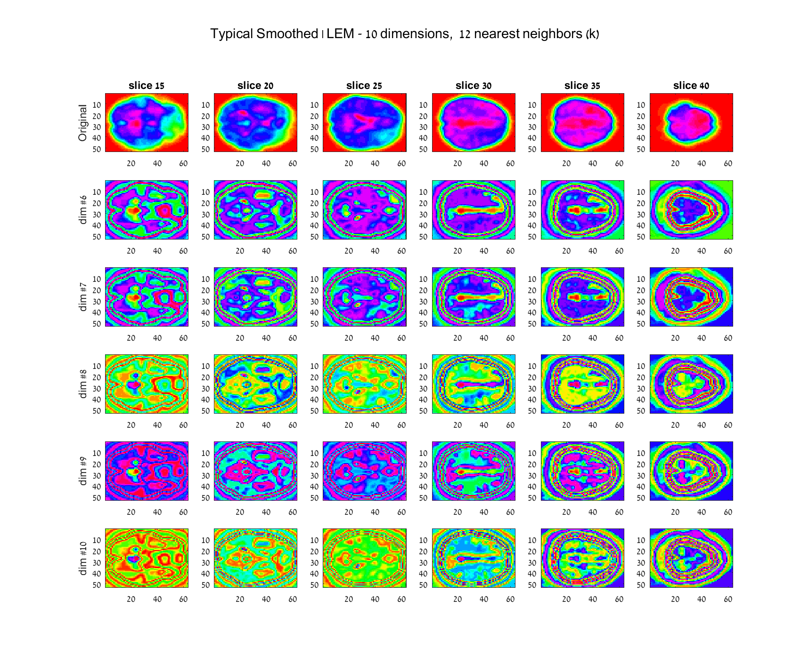

### Typical study, 10 dimensions, 14 nearest neighbors

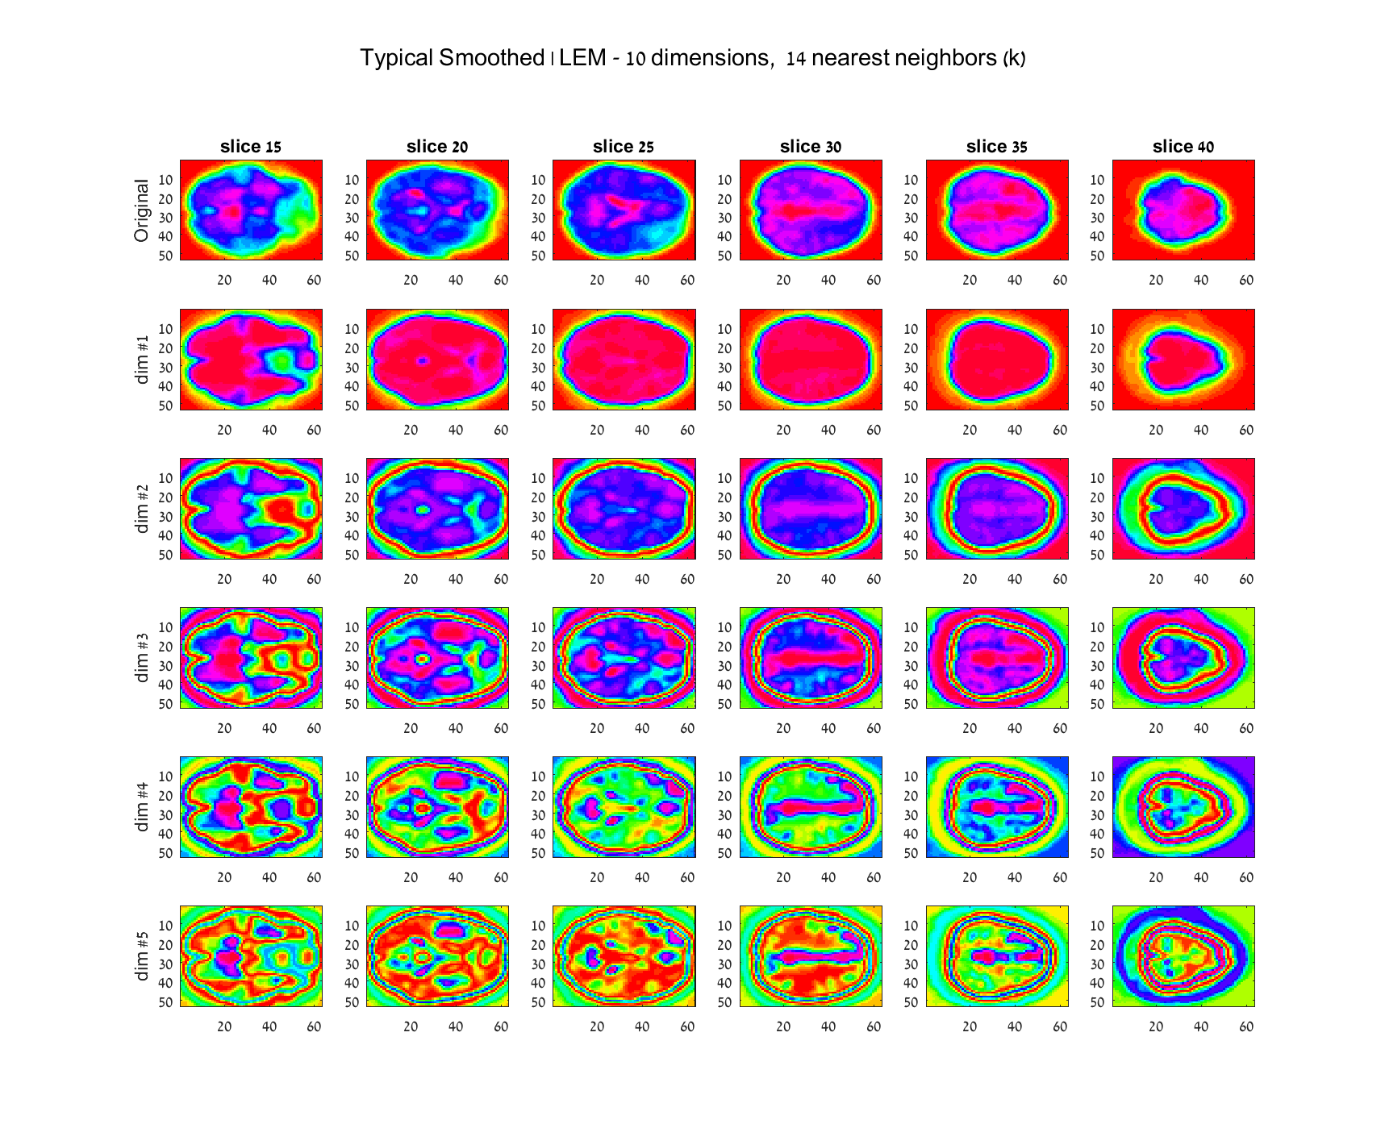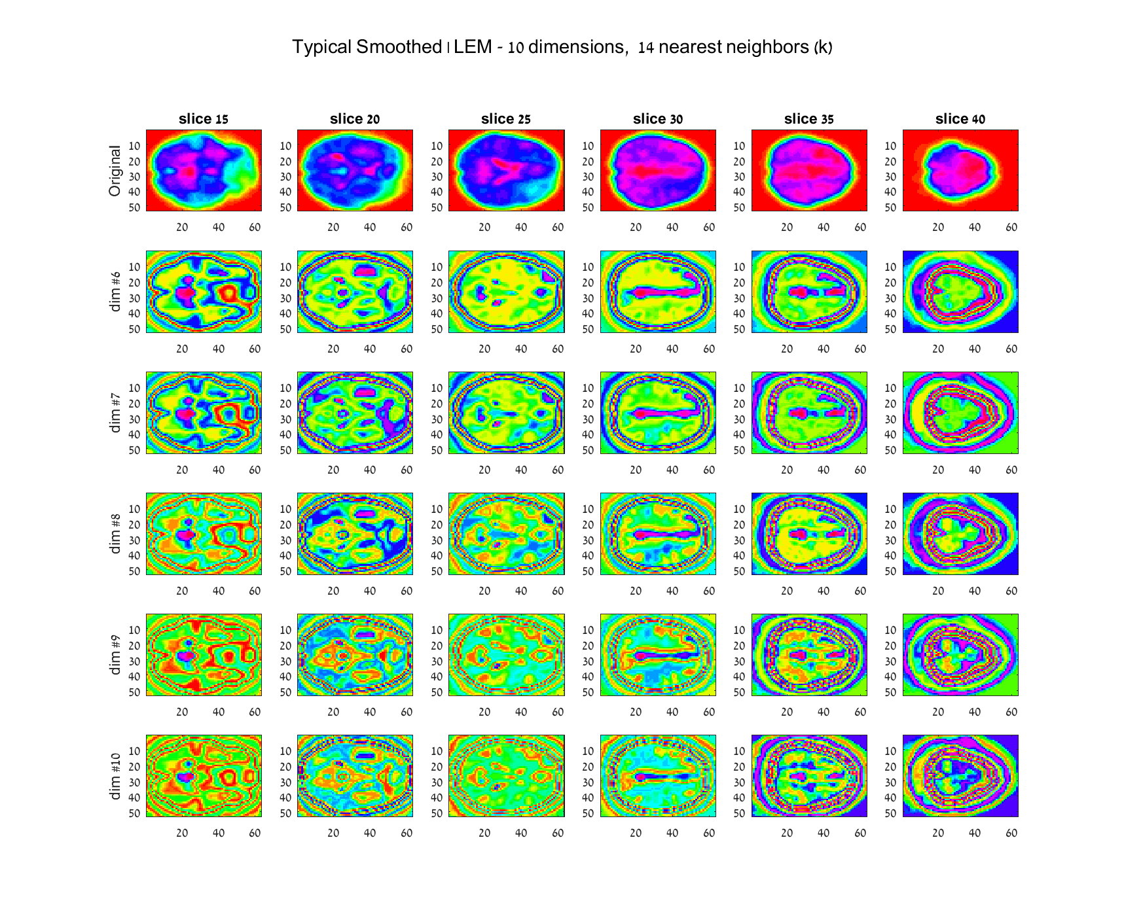

### Typical study, 10 dimensions, 16 nearest neighbors

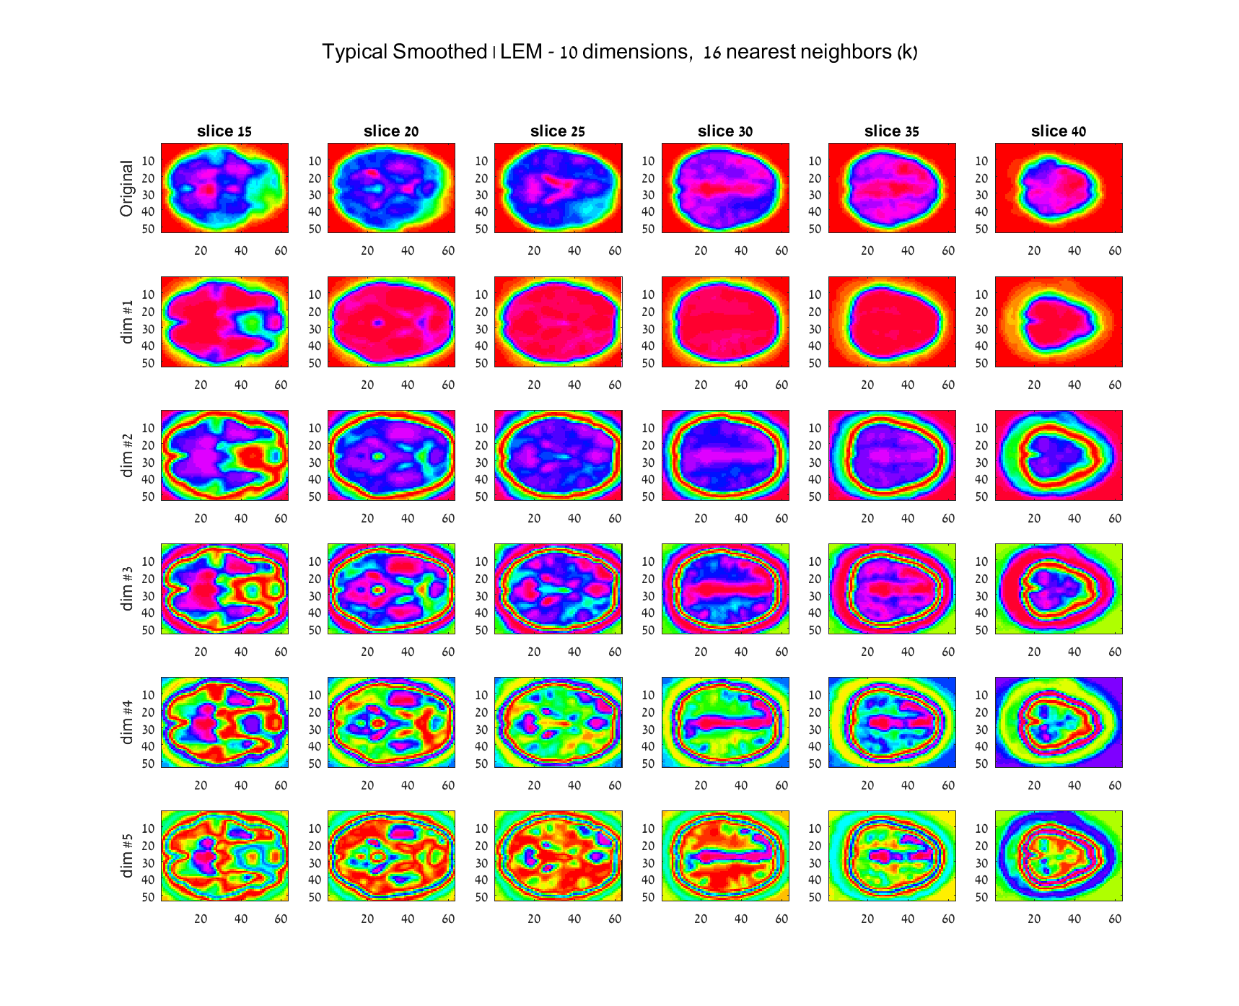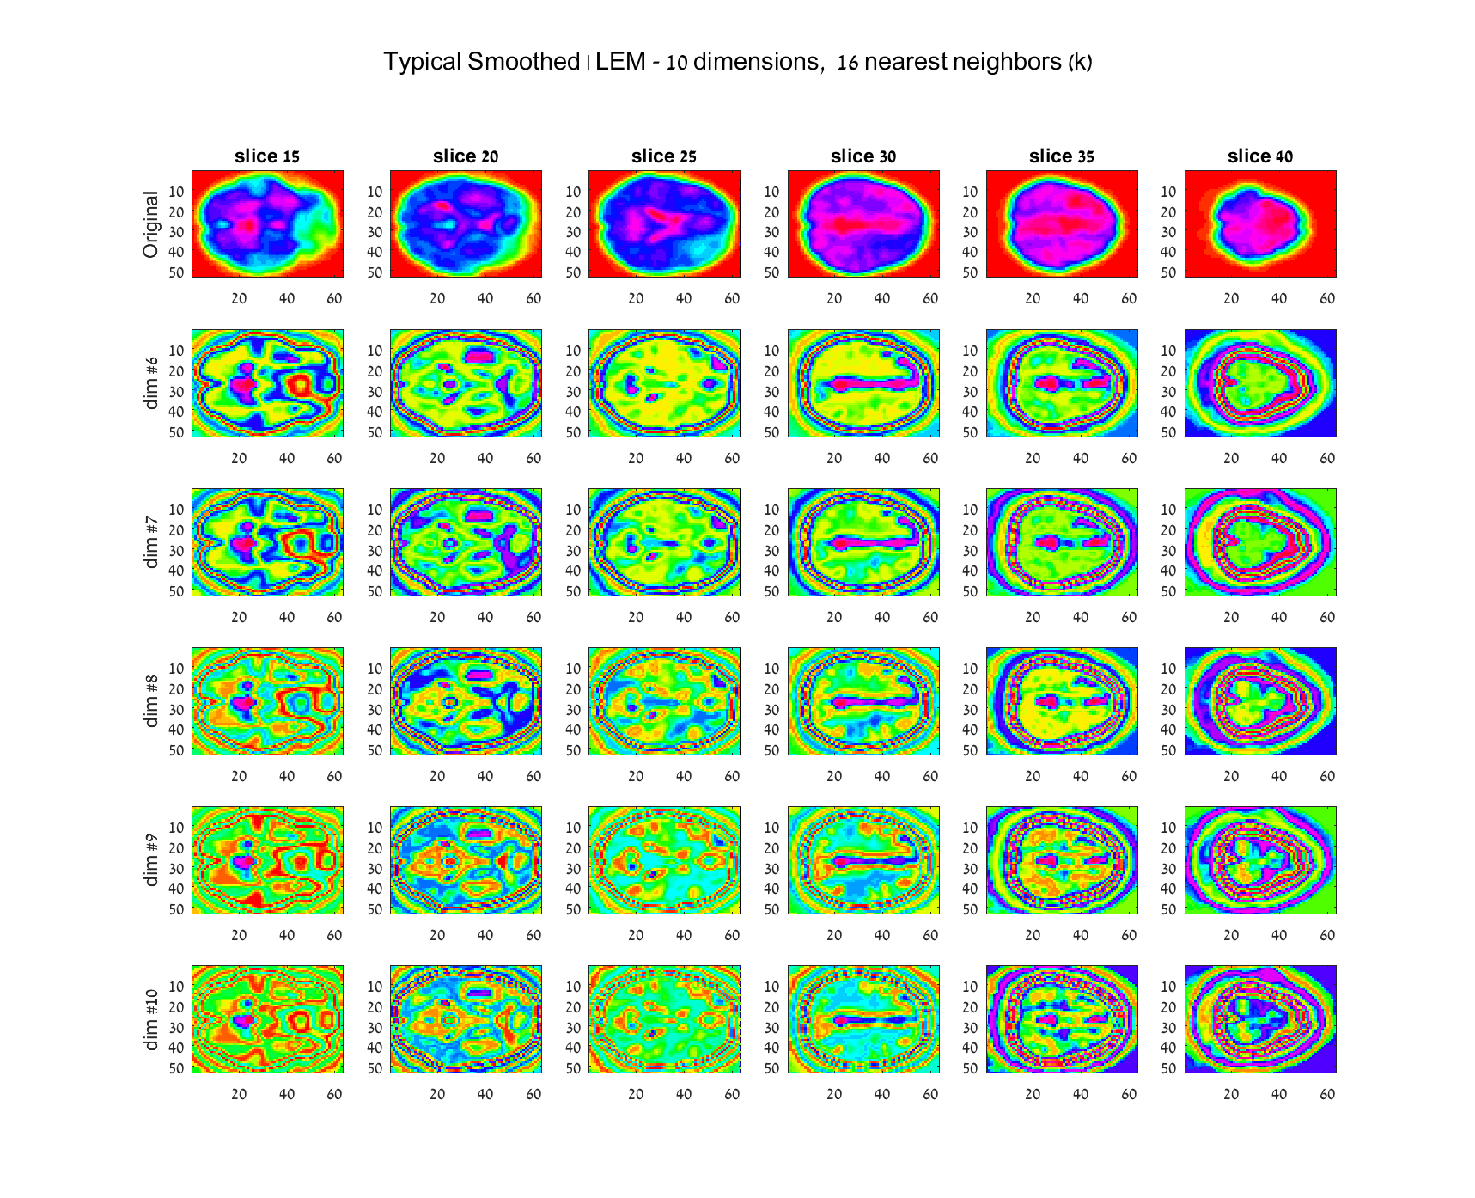

### Typical study, 10 dimensions, 18 nearest neighbors

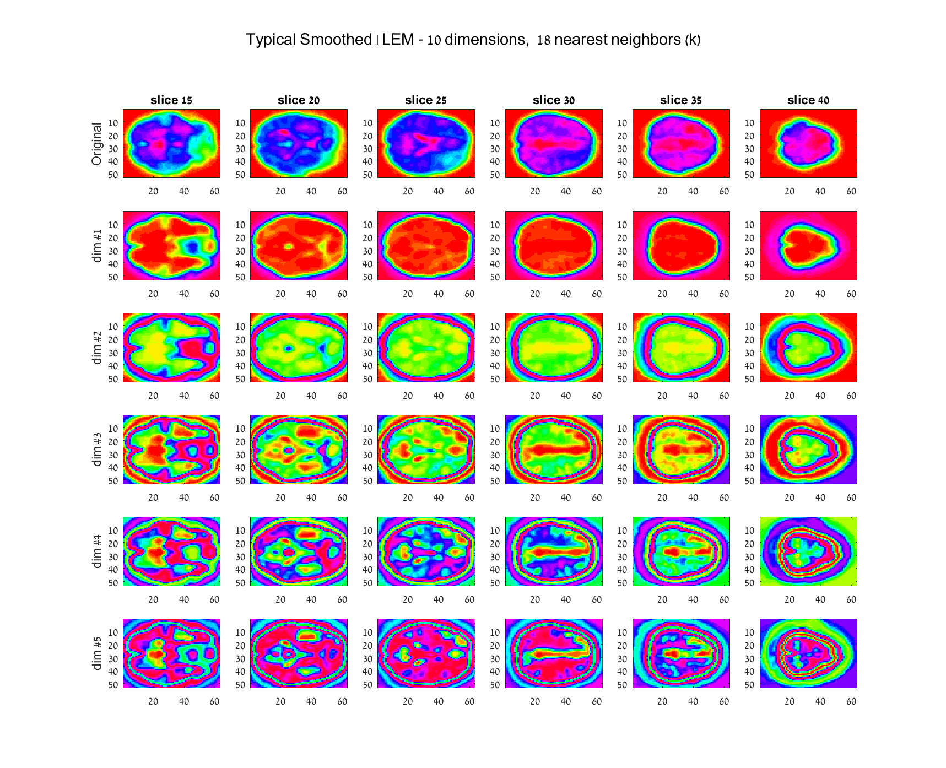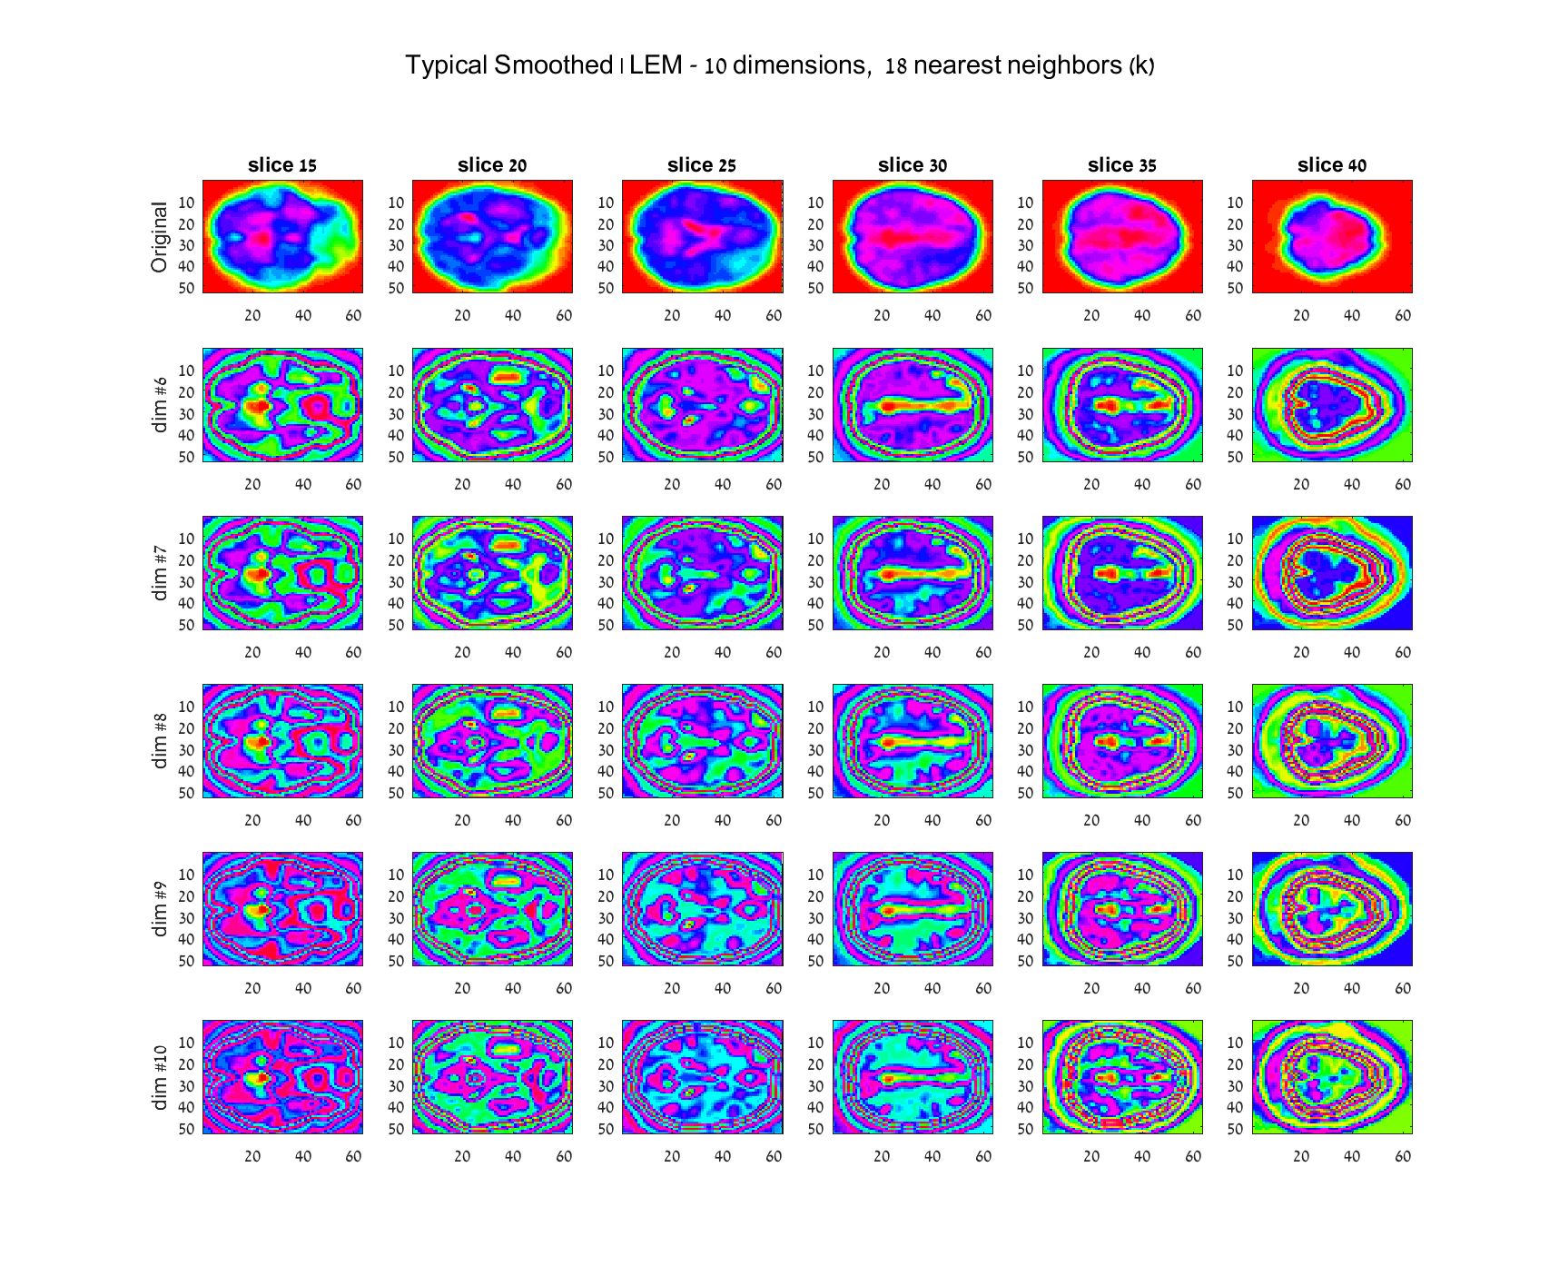

### Typical study, 10 dimensions, 20 nearest neighbors

## **typical_smoothed_LEM_dim10_k20_noClustering1-5typical_smoothed_LEM_dim10_k20_noClustering6-10**

## **Appendix 2 – Additional results for temporal concatenation group analysis using different values of $σ$**

### $σ=0.5$, Typical Group

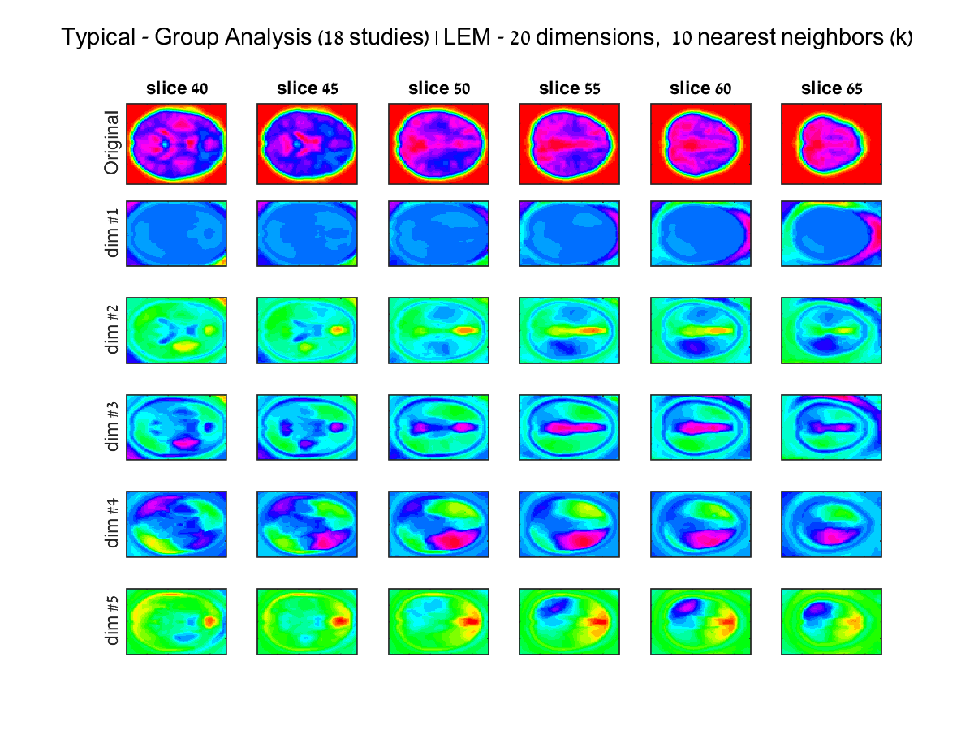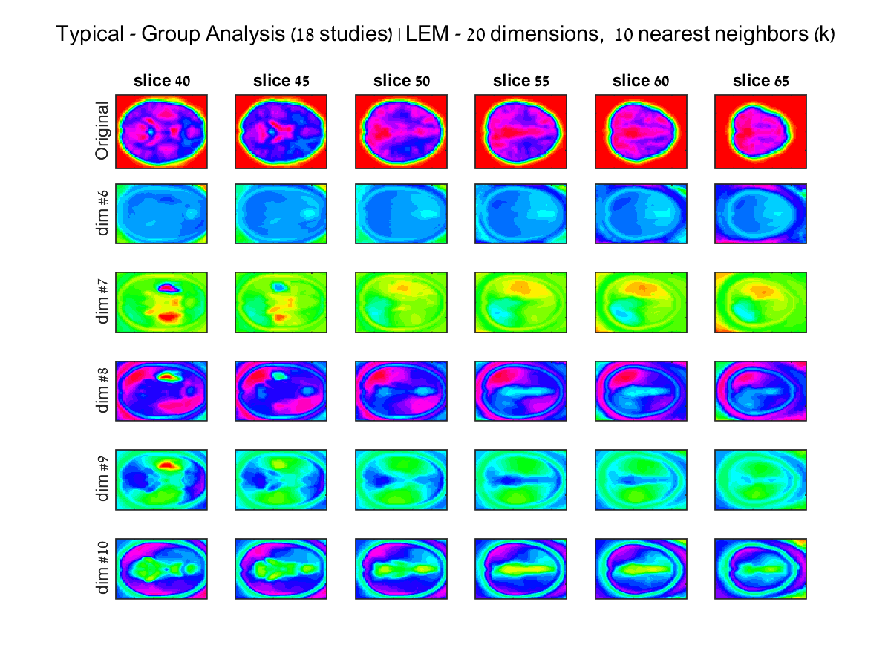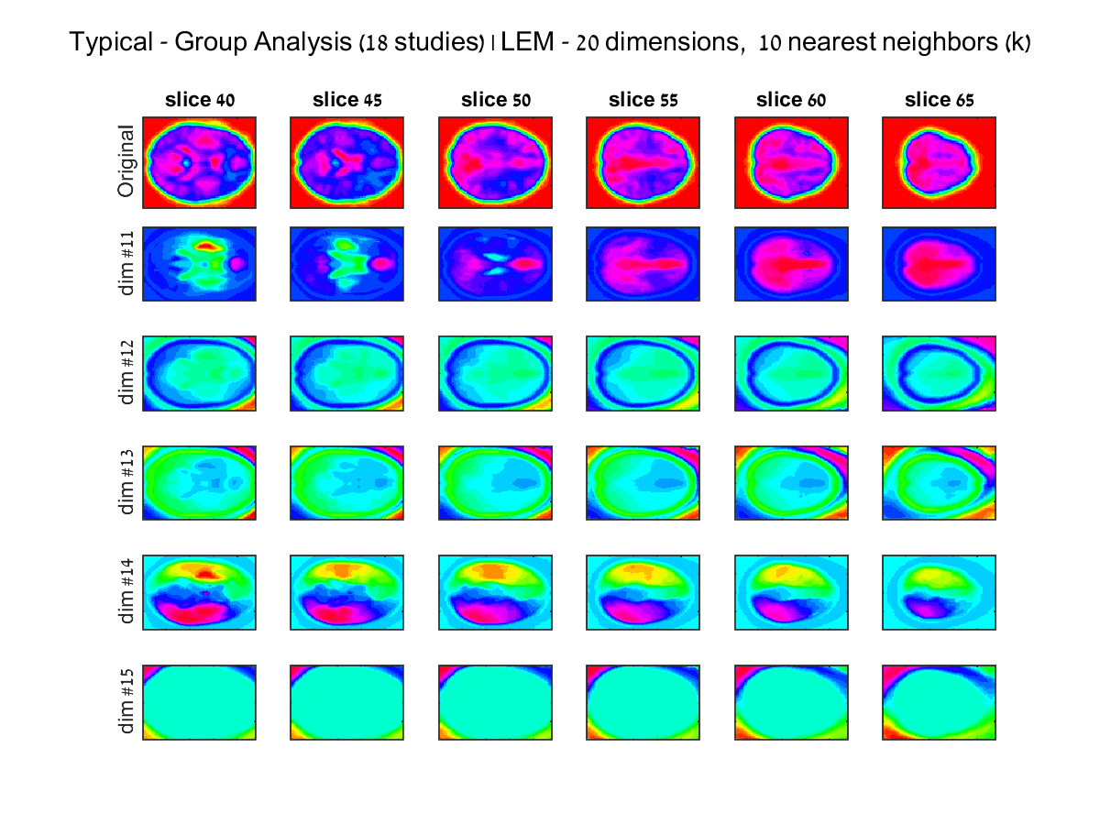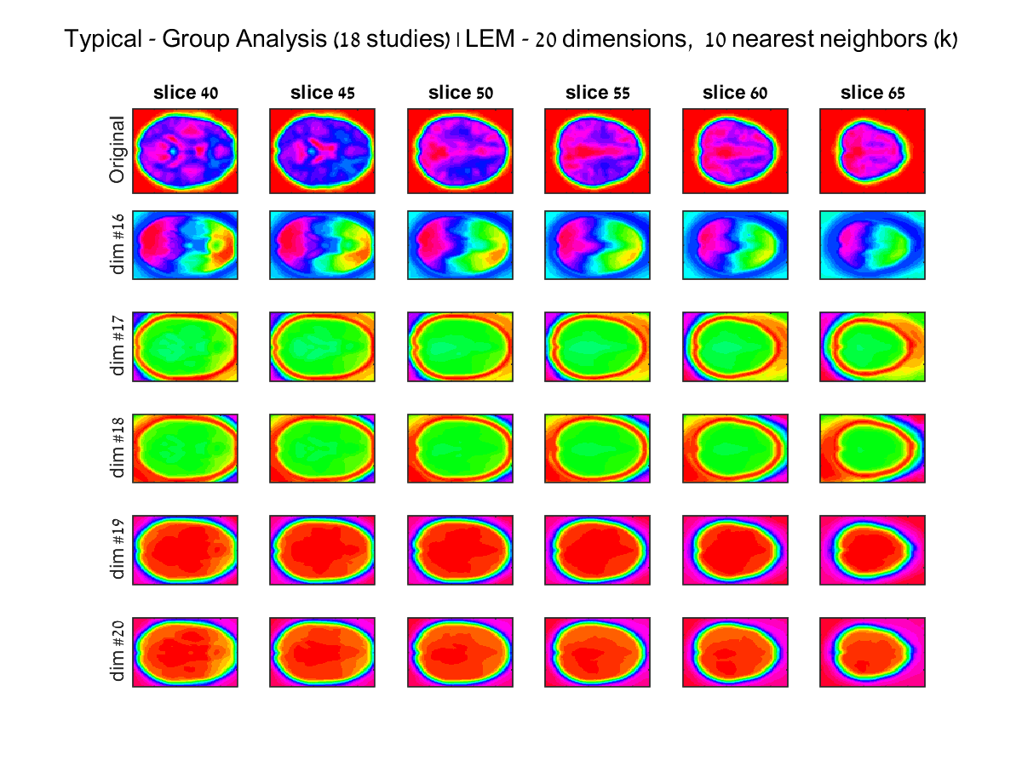

### $σ=1.5$, Typical Group

**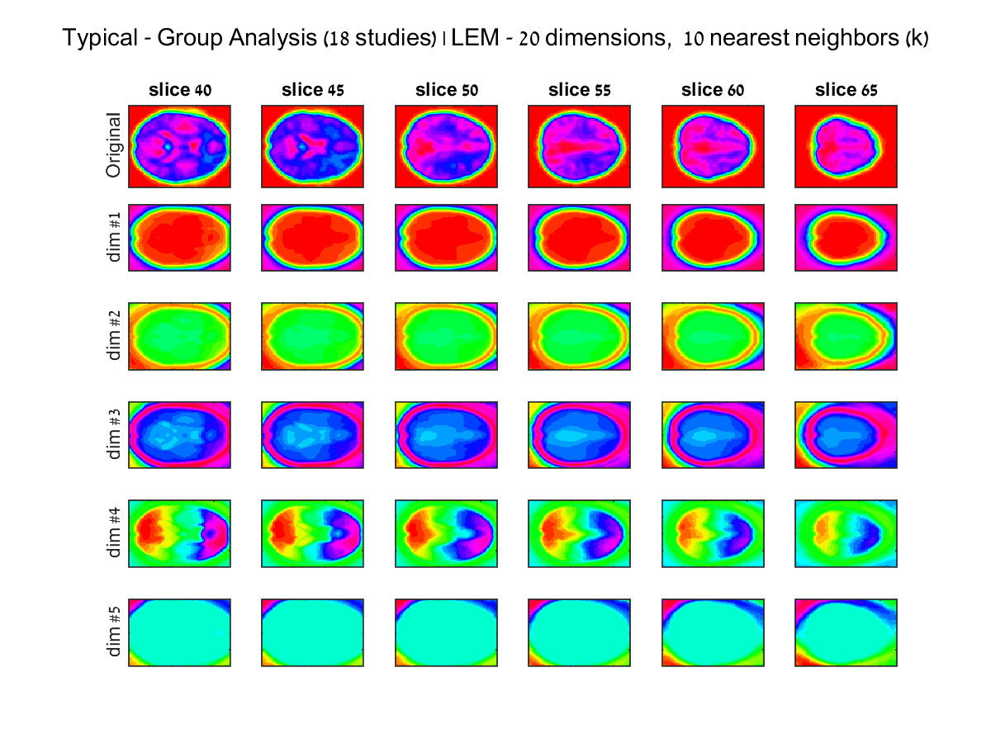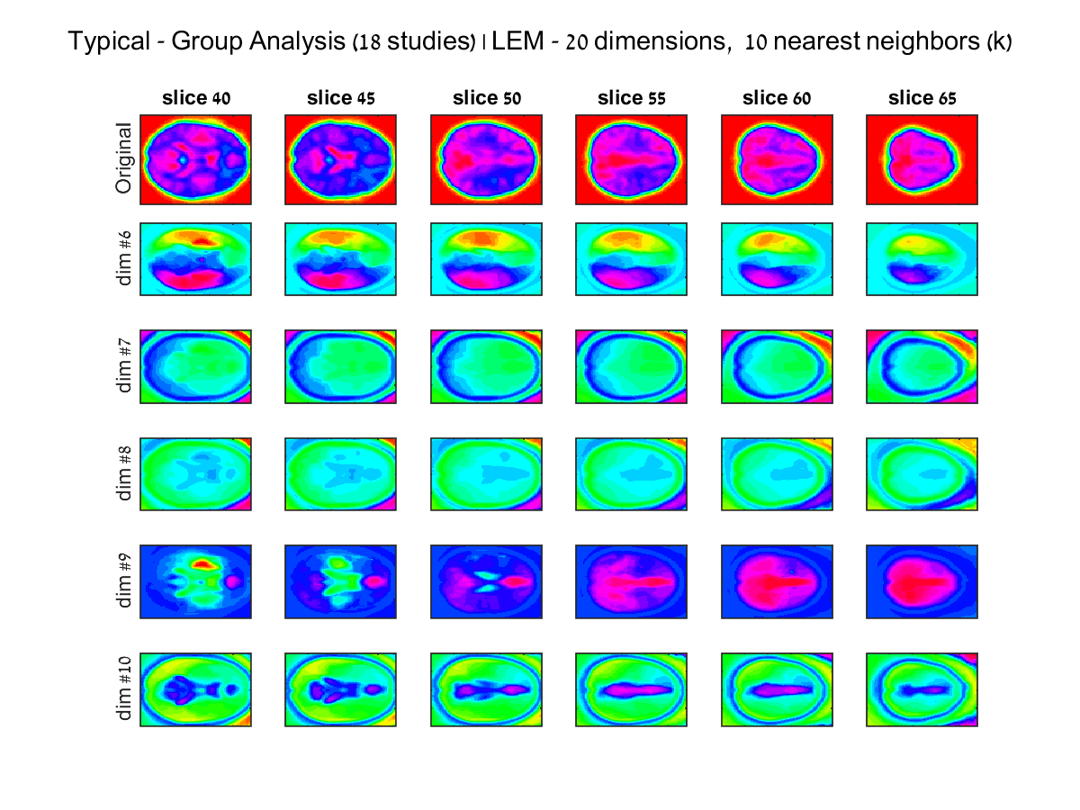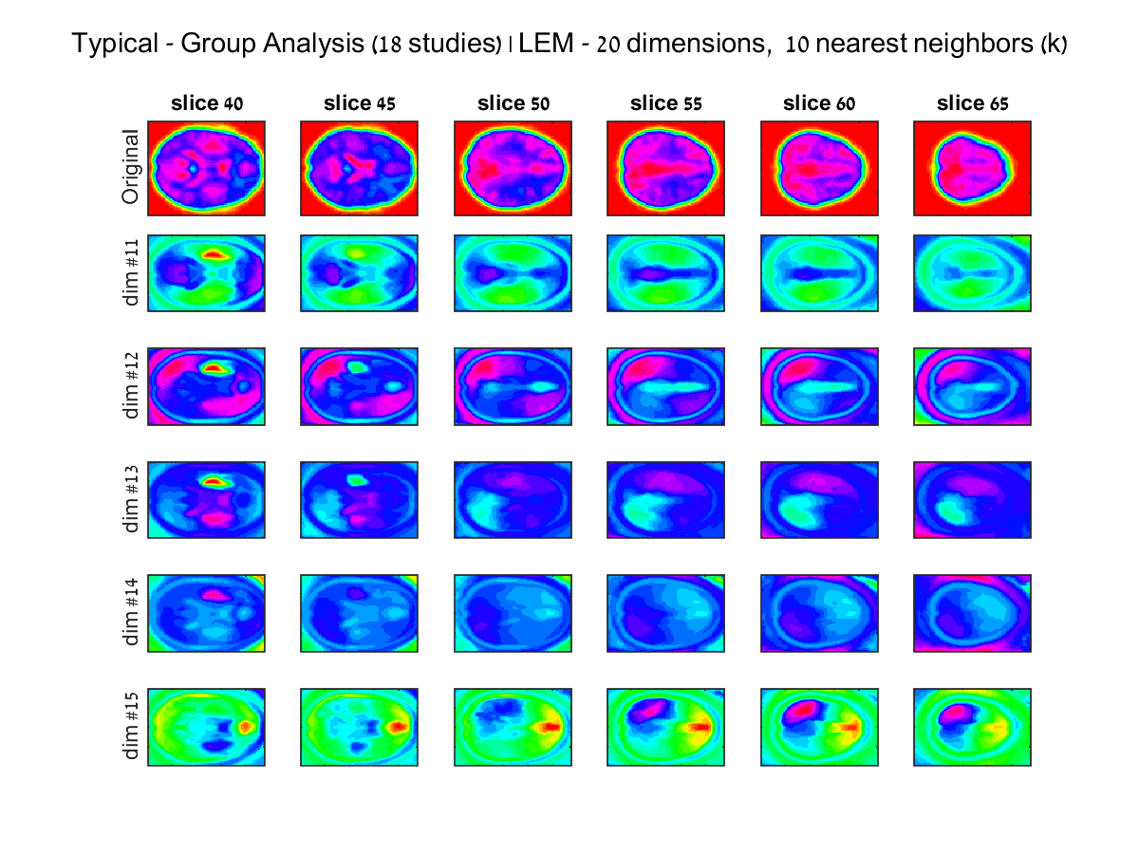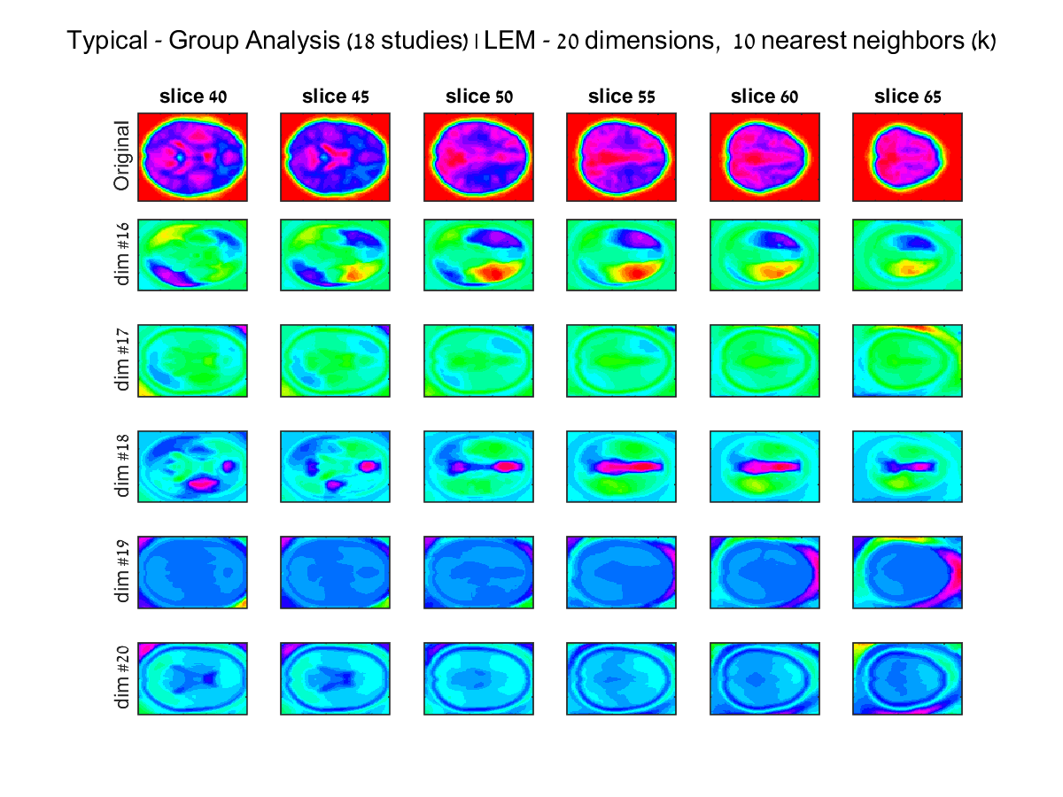**

## **Appendix 3 – Additional results for mean eigen decomposition group analysis using different block sizes**

### Typical Group, 10 iterations, block size 100

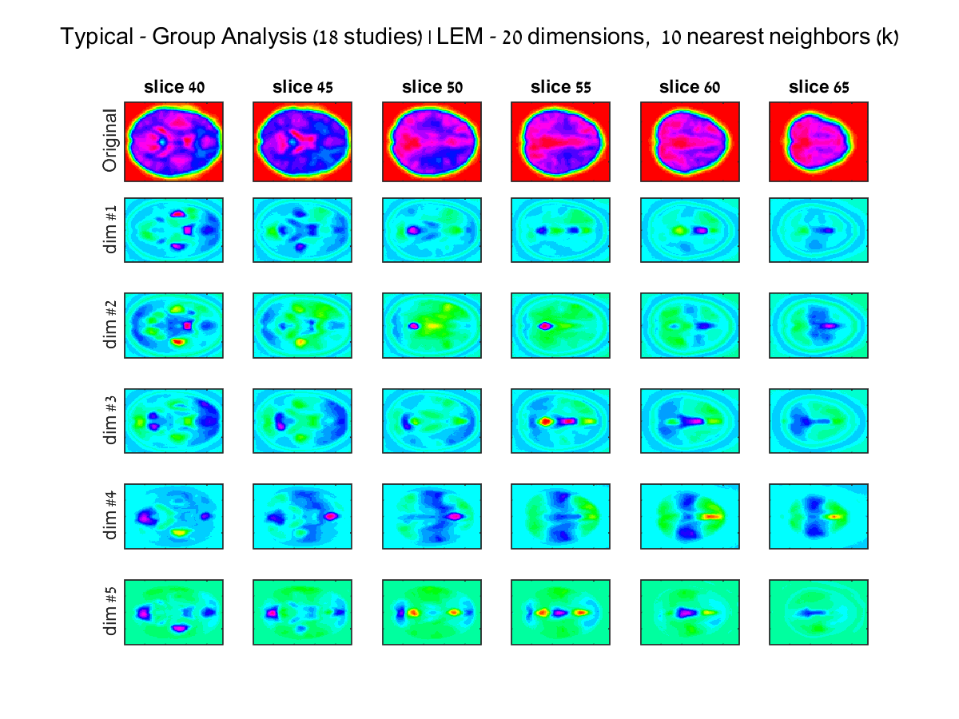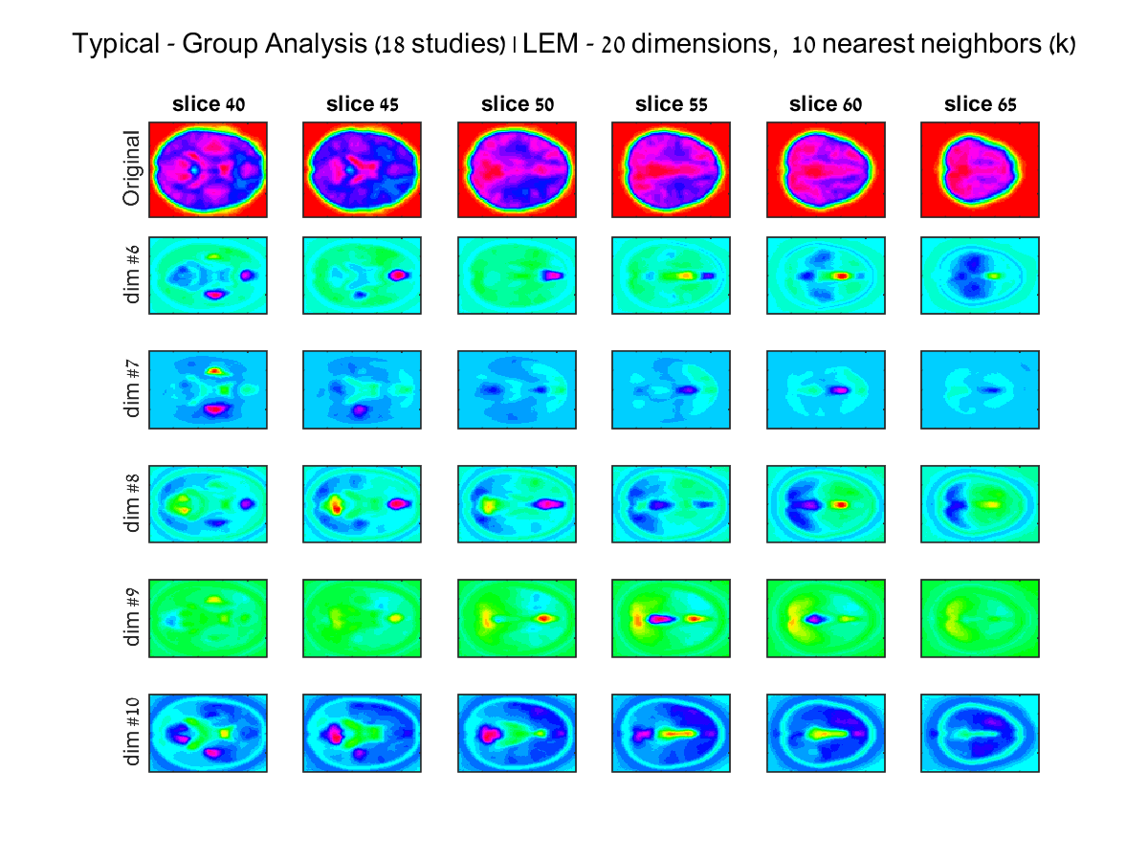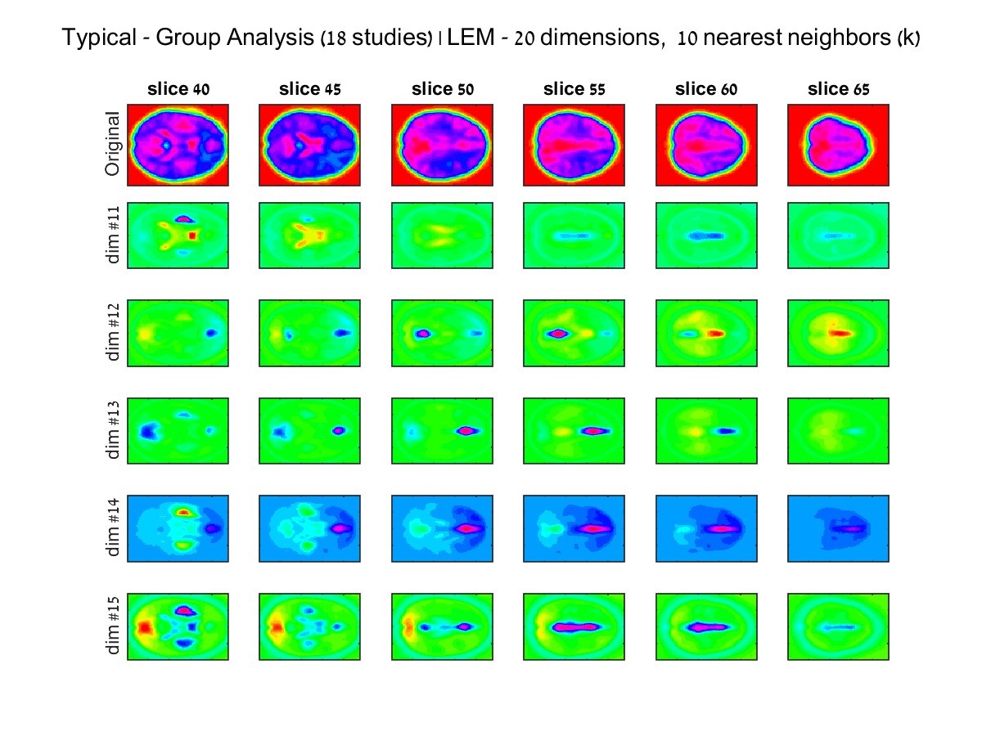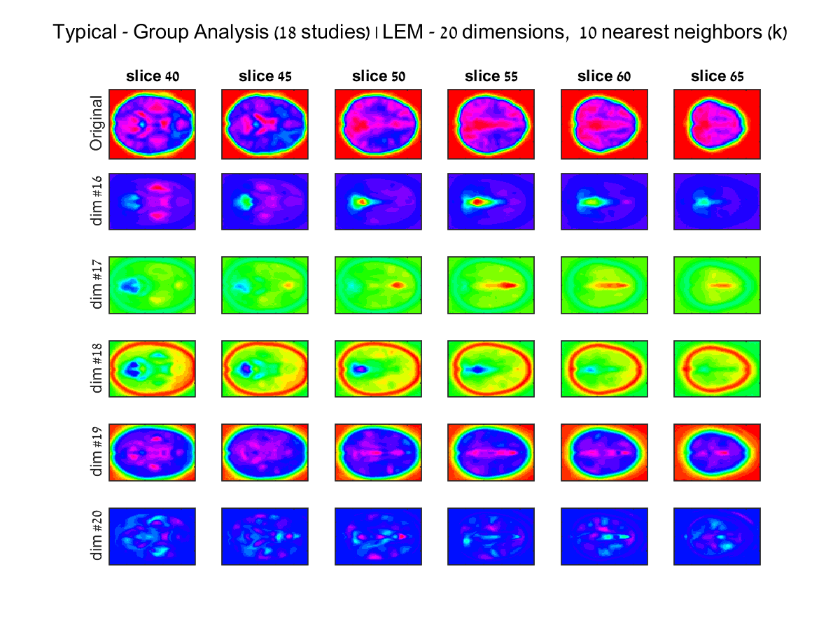

### Typical Group, 10 iterations, block size 500

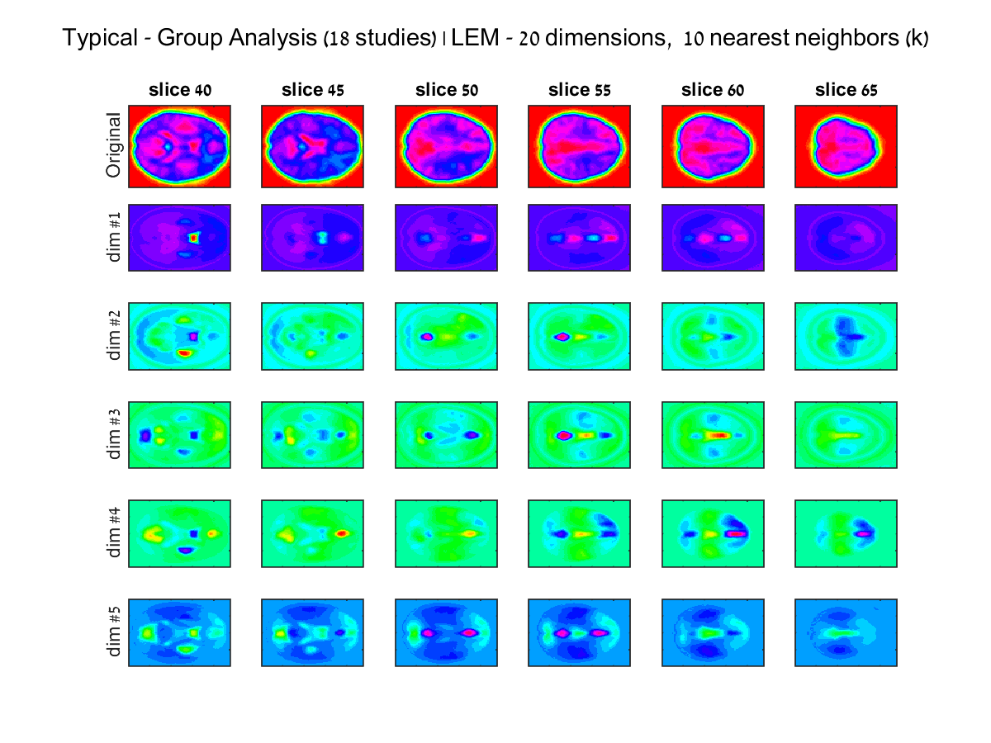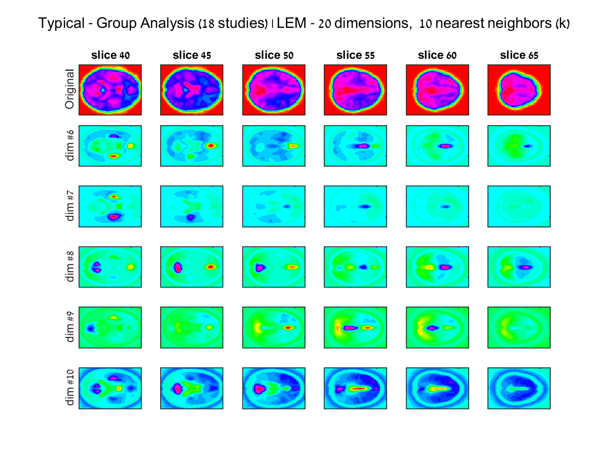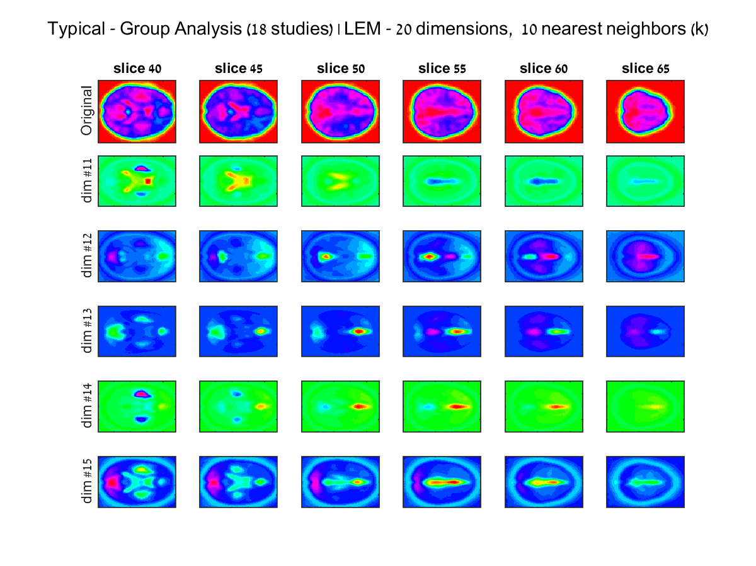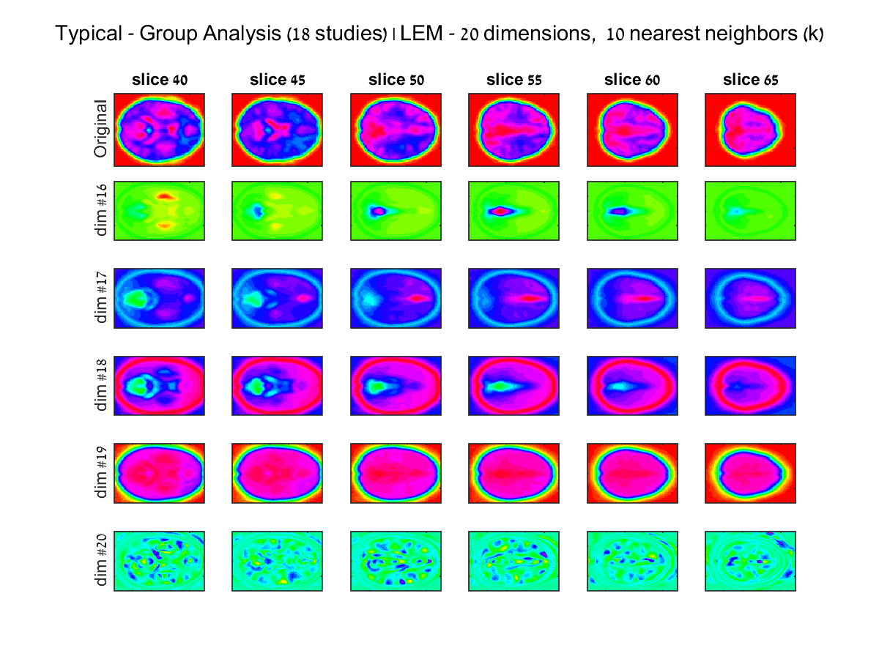

## **Appendix 4 – Additional results for mean eigen decomposition group analysis after clustering using K means**

### Typical Group, 10 iterations, block size 1000



### Dyslexic Group, 10 iterations, block size 1000

